Web Design and Development

4COSC011W

Report

Author: Kankanige Mareen Sasiru Vishmika Perera

IIT ID: 20211267

UOW ID: w1899317

Group Number: Group G3

Student Role: Student 4

1. Introduction 3

2. Technical Discussion 5

3. Webpage Validation Statement 10

4. Janet 10

References 11

Appendices 12

Appendix A: Code 12

Appendix B: Screenshots 97

Appendix C: Screenshots - Webpage Validation Evidence 110

Appendix D: Individual Statement 112

# Introduction

1. List of team members
2. Akash Suresh Student 1
3. N.A.A.N.A. Senarathna Student 2
4. B.A.R.S. Perera Student 3
5. K.M.S.V. Perera Student 4
6. Website name – GameStop

This website is created to spread the latest news and updates about computer  
games, there functionality with technical side and as a place to sell related product on gaming.

This report created under the roll of student 4. It includes how I implemented the work of student roll 4 in this website.

|  |  |  |
| --- | --- | --- |
| **Group Coursework Meetings** | | |
| **1** | **Date & Time** | **24th June 2022 (Online) / 9.00 a.m. to 10.30 a.m.** |
| **Objective:** | **To agree website topic and assign student roles** |
| **Attended:** | **All students attended** |
| **Your Contribution:** | **I suggested the topic gaming as my suggestion after discussing we agree to do a website on gaming and took the student role 4.** |
| **2** | **Date & Time:** | **26th June 2022 (Online) / 5.00 p.m. to 6.40 p.m.** |
| **Objective:** | **To discuss about the design of main page and the things related to navigation bar** |
| **Attended:** | **All students attended** |
| **Your Contribution:** | **I suggested content for additional page as game engines and I suggested having a Shop page to buy products, contact us page and a login page.** |
| **3** | **Date & Time:** | **6th July 2022 (Online) / 5.00 p.m. to 6.10 p.m.** |
| **Objective:** | **To discuss about the additional content page** |
| **Attended:** | **3 students attended (including myself)** |
| **Your Contribution:** | **I discussed with my team members and planned a layout for additional content page and the main page. Also, I selected to create the section of the additional content page regarding the topic “Unreal engine” and to create a section of the main page “Latest and upcoming games”.** |
| **4** | **Date & Time:** | **9th of July 2022 (Online) / 2.00 p.m. to 3.50 p.m.** |
| **Objective:** | **To further discuss about the main page, additional content page, logo and a title for our website.** |
| **Attended:** | **All students attended** |
| **Your Contribution:** | **I discussed with others and came up with the name Game Spot for our website and videos we can include in our additional content page. Also, we discussed as a team and selected an intro video to be embedded in our main page and transition effects for it.** |
| **5** | **Date & Time:** | **11th of July 2022 (Online) / 9.00 a.m. to 11.30 a.m.** |
|  | **Objective:** | **To make further improvements in our web pages.** |
|  | **Attended:** | **All students attended** |
|  | **Your Contribution:** | **I showed the web pages that I had developed so far to my team members and some sample logos I created for the website then discussed how I can improve them. I suggested including the heading for each page inside a div and giving it a background image with font color white.** |
| **6** | **Date & Time:** | **14th of July 2022 (Online) / 11.00 a.m. to 3.00 p.m.** |
| **Objective:** | **Website Integration** |
| **Attended:** | **3 students attended including myself.** |
| **Your Contribution:** | **I suggested how we can fix errors we faced during integration.** |
| **7** | **Date & Time:** | **16th of July 2022 (Online) / 9.00 a.m. to 12.30 p.m.** |
| **Objective:** | **Final Validation** |
| **Attended:** | **All students attended** |
| **Your Contribution:** | **We reviewed our website and fixed final errors and did our individual page validations.** |

# Technical Discussion

This technical discussion is for student roll 4 tasks only. Within given tasks I had to complete

* Sitemap for the webpage
* Thumbnail images page that will show a larger description when an image is selected
* Change the text colour and background colour in the thumbnail images page

1. **Sitemap for the webpage**

I created the diagram for sitemap using html svg graphics. I used basic shapes to create it and I used a path element inside a marker element and implemented it into end of each line with css to create the arrowhead at the end of each line.

Below show how I used rect element to create the home page svg and main horizontal bar of the diagram.

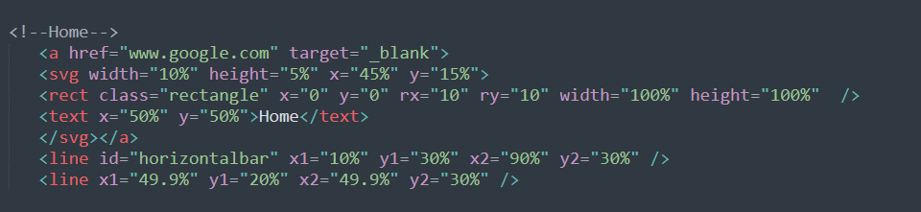

As above I created svg element inside of separate svg tags and position them using x and y coordinates, but it took some time to properly align lines and rectangles.

After that I add anchor tags to each svg to link them to relevant parts of the website and I used css to do additional styling as changing the text colour, adding a hover effect and to change the fill and stroke color of rectangles and lines.

1. **Thumbnail images page**

In this page I had to add 5 different images and once the user selects one a larger description about that image should display. Since our website topic is gaming, I took this page as collection page and used 5 images that categories different types of computer games as thumbnail images.

Below code shows how I implemented one of the 5 images.

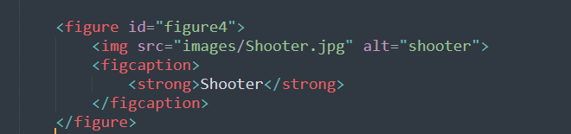

And below code shows the related description for above image

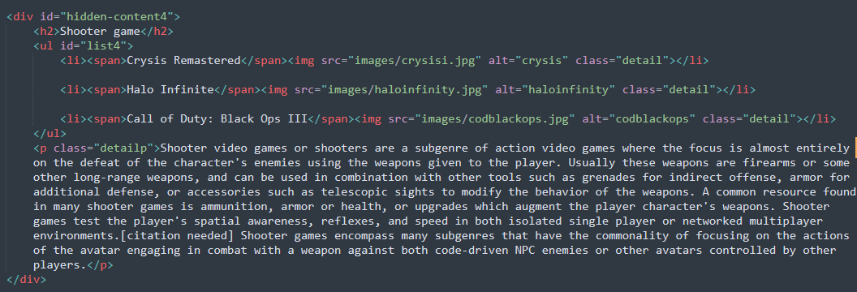

Below is the css code snippet I used to style all the related descriptions.

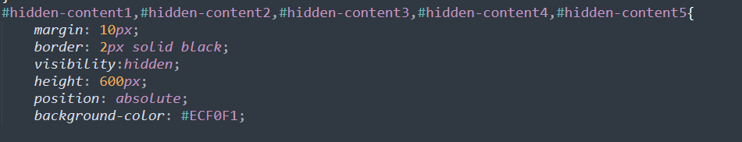

I used visibility type hidden for each of the description so by default all of them will be hidden. I used mouseover event Listener for thumbnail images and when mouser is over one of them below java script code will run and relevant mouseover function will set css visibility property value to visible only for the description of that image.

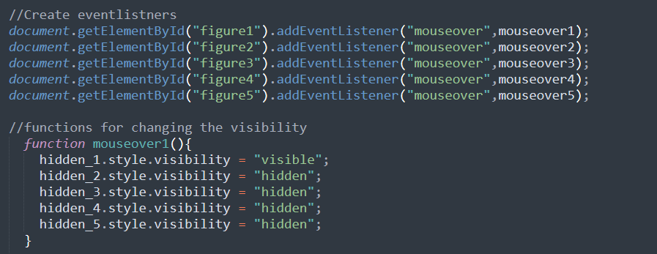

“Hidden_1,2,3,4,5” are variables created to represent the relevant descriptions to minimize the code duplication.

So, like this I created 5 mouseover function for each “figure” and each of them will function as the above code and setting their relevant description visibility to visible.

1. **Changing the text and background colour**

When the user selects a colour from a dropdown list, I had to change the background and text colour of the collection page, so I created two drop down menus for text colour and background colour each with 4 different colours.

Below is the code for first drop-down menu.

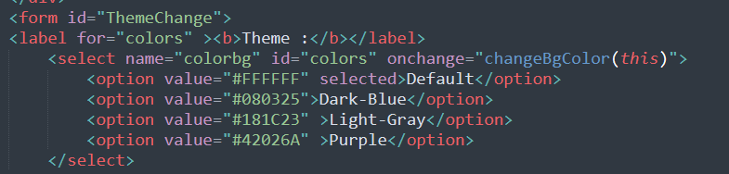

I used event onchange to assign a javascript function named “changeBgcolor ()” in the first menu. When the user selects one option from the drop-down menu this function will be called. “this” key word act as an argument and pass relevant html element to the function in this case the option element.

below shows the javascript code for the function.

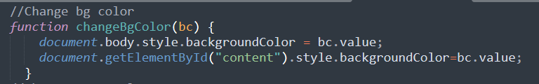

This function will change the background colour of the body to the value selected by user from the drop-down menu. Second line of the code in the function only to ensure the background colour of content area is also change according to the user’s choice.

Below code is for the second drop-down menu.

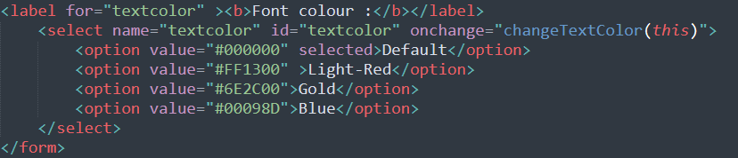

When the user selects an option function “changeTextColor ()” will be called and below java script code snippet will run and it will change the text colour to the value user selected.

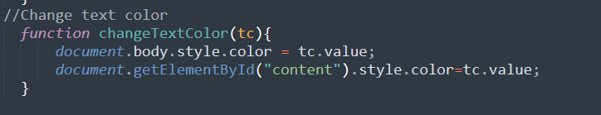

**Main page section and additional page section**

I created a section on upcoming games as my contribution for main page. Here I used 6 div tags and put one image in each one of them along with a related short description. This section is entirely created from html and css.

Html code for one of the div item is shown below.

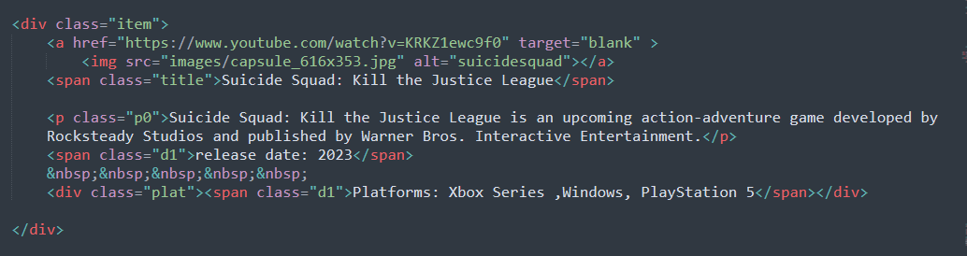

I created a section on unreal engine as my contribution for additional page. Code snippet taken from additional page unreal engine section shown below.

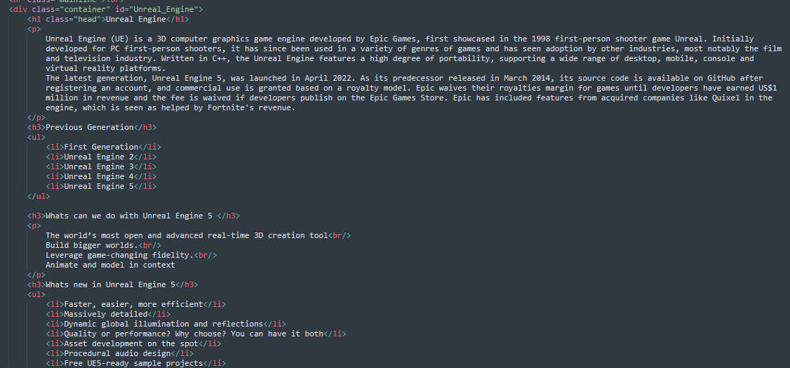

# Webpage Validation Statement

I validated all the html web pages I have created (CollectionNew.html, Sitemap.html, PageEditor.html).  
I have added screenshots as evidence of validation in Appendix C.

# Janet

This website is created according to the Janet regulations and policies. This website will not allow the transmission or creation of any obscene or offensive material, and it doesn’t include any material of threatening nature or libelous nature and only provide the information that users need. You will not find any other person content in the site all the content shown are our own and this content doesn’t intend to defame any individuals or organizations. This website doesn’t contain any fraud technique that intended to steal users’ personal data and if the website ask for your information data that you entered will never be given to any individuals or companies. We highly value the user privacy so user data will be protected and handled carefully, and these user data will not be stored in the website so users can use our website safely.

# References

W3Schools, Available at: <https://www.w3schools.com/html/html5_svg.asp> (Accessed: 12th of July 2022).

GeeksforGeeks, Available at: <https://www.geeksforgeeks.org/hide-or-show-html-elements-using-visibility-property-in-javascript/> (Accessed: 15th of July 2022).

# Appendices

## Appendix A: Code

**File name - CollectionNew.html**

<!doctype html>

<html lang="en">

<head>

<title>Collection</title>

<meta charset="utf-8">

<link href="CollectionNew.css" type="text/css" rel="stylesheet">

<link rel="stylesheet" href="ExternalCss.css">

<!--CSS for navigation panel and footer-->

<link rel="stylesheet" href="navigation.css">

<link rel="stylesheet" href="style1.css">

<link rel="stylesheet" href="https://stackpath.bootstrapcdn.com/font-awesome/4.7.0/css/font-awesome.min.css" integrity="sha384-wvfXpqpZZVQGK6TAh5PVlGOfQNHSoD2xbE+QkPxCAFlNEevoEH3Sl0sibVcOQVnN" crossorigin="anonymous">

<link rel="stylesheet" type="text/css" href="Styles.css">

</head>

<body>

<nav>

<div class="navigation_bar" >

<img id="navLogo" src="Logo/logo_nav.png" alt="fade effect">

<ul class="menu_area">

<li><a href="Sitemap.html"> Site map </a></li>

<li><a href="About_Us.html"> About us </a></li>

<li><a href="QueryForm.html"> Contact us </a></li>

<li><a href="Game_Engines.html">Engines </a></li>

<li><a href="Quiz2.html"> Quize </a></li>

<li><a href="Collection.html"> Collection </a></li>

<li><a href="Shop.html"> Shop </a></li>

<li class="active"><a href="mainPage.html">Home</a></li>

</ul>

</div>

</nav>

<div class="container">

<div id="topic">

<h1>COLLECTION</h1>

</div>

<!-- to change the background colour-->

<form id="ThemeChange">

<label for="colors" ><b>Theme :</b></label>

<select name="colorbg" id="colors" onchange="changeBgColor(this)">

<option value="#FFFFFF" selected>Default</option>

<option value="#080325">Dark-Blue</option>

<option value="#181C23" >Light-Gray</option>

<option value="#42026A" >Purple</option>

</select>

&nbsp;&nbsp;

<!-- to change the text colour-->

<label for="textcolor" ><b>Font colour :</b></label>

<select name="textcolor" id="textcolor" onchange="changeTextColor(this)">

<option value="#000000" selected>Default</option>

<option value="#FF1300" >Light-Red</option>

<option value="#6E2C00">Gold</option>

<option value="#00098D">Blue</option>

</select>

</form>

<!-- thumbnail images-->

<div id="gallery">

<figure id="figure1">

<img src="images/Sports.jpg" alt="sport" >

<figcaption>

<strong>Sports</strong>

</figcaption>

</figure>

<figure id="figure2">

<img src="images/ActionAdventure.jpg" alt="Action_adventure">

<figcaption>

<strong>Action & Adventure</strong>

</figcaption>

</figure>

<figure id="figure3">

<img src="images/BattleRoyal.jpg" alt="multiplayer">

<figcaption>

<strong>Multiplayer</strong>

</figcaption>

</figure>

<figure id="figure4">

<img src="images/Shooter.jpg" alt="shooter">

<figcaption>

<strong>Shooter</strong>

</figcaption>

</figure>

<figure id="figure5">

<img src="images/Horror.jpg" alt="horror">

<figcaption>

<strong>Horror</strong>

</figcaption>

</figure>

</div>

<!-- content display when select a thumbnail-->

<div id="content">

<div id="hidden-content1">

<h2>Games that Simulate practice of Sports</h2>

<ul id="list1">

<li><span>FIFA 2022</span><img src="images/fifa.jpg" alt="fifa22" class="detail"></li>

<li><span>NBA 2020</span><img src="images/basketball-NBA2K20.jpg" alt="nba22" class="detail"></li>

<li><span>F1 2018</span><img src="images/formula1.jpg" alt="f1" class="detail"></li>

</ul>

<p class="detailp">A sports video game is a video game that simulates the practice of sports. Most sports have been recreated with a game, including team sports, track and field, extreme sports, and combat sports. Some games emphasize actually playing the sport (such as FIFA, Pro Evolution Soccer and Madden NFL), whilst others emphasize strategy and sport management (such as Football Manager and Out of the Park Baseball). Some, such as Need for Speed, Arch Rivals and Punch-Out!!, satirize the sport for comic effect. This genre has been popular throughout the history of video games and is competitive, just like real-world sports. A number of game series feature the names and characteristics of real teams and players, and are updated annually to reflect real-world changes. The sports genre is one of the oldest genres in gaming history.</p>

</div>

<div id="hidden-content2">

<h2>Action-adventure game</h2>

<ul id="list2">

<li><span>The Witcher 3: Wild Hunt</span><img src="images/EGS_TheWitcher33e.jpg" alt="witcher3" class="detail"></li>

<li><span>Red Dead Redemption 2</span><img src="images/Rdr2.jpg" alt="RDR2" class="detail"></li>

<li><span>God of War</span><img src="images/godofWar.jpg" alt="gow4" class="detail"></li>

</ul>

<p class="detailp">The action-adventure genre is a video game genre that combines core elements from both the action game and adventure game genres. Action-adventure is a hybrid genre and can include many games which might better be categorized under more narrow genres. Typically, pure adventure games have situational problems for the player to solve, with very little or no action. If there is action, it is generally confined to isolated minigames. Pure action games have gameplay based on real-time interactions that challenge the reflexes. Therefore, action-adventure games engage both reflexes and problem-solving in both violent and non-violent situations.</p>

</div>

<div id="hidden-content3">

<h2>Multiplayer video game</h2>

<ul id="list3">

<li><span>Fortnite</span><img src="images/fortnite.jpg" alt="fortnite" class="detail"></li>

<li><span>PlayerUnknown's Battlegrounds</span><img src="images/pubg-pc2.jpg" alt="pubgpc" class="detail"></li>

<li><span>Call of Duty: Warzone</span><img src="images/warzone.jpg" alt="codwarzone" class="detail"></li>

</ul>

<p class="detailp">A multiplayer video game is a video game in which more than one person can play in the same game environment at the same time, either locally and on the same computing system (couch co-op), locally and on different computing systems via a local area network, or via a wide area network, most commonly the Internet (e.g. World of Warcraft, Call of Duty). Multiplayer games usually require players to share a single game system or use networking technology to play together over a greater distance; players may compete against one or more human contestants, work cooperatively with a human partner to achieve a common goal, or supervise other players' activity. Due to multiplayer games allowing players to interact with other individuals, they provide an element of social communication absent from single-player games.</p>

</div>

<div id="hidden-content4">

<h2>Shooter game</h2>

<ul id="list4">

<li><span>Crysis Remastered</span><img src="images/crysisi.jpg" alt="crysis" class="detail"></li>

<li><span>Halo Infinite</span><img src="images/haloinfinity.jpg" alt="haloinfinity" class="detail"></li>

<li><span>Call of Duty: Black Ops III</span><img src="images/codblackops.jpg" alt="codblackops" class="detail"></li>

</ul>

<p class="detailp">Shooter video games or shooters are a subgenre of action video games where the focus is almost entirely on the defeat of the character's enemies using the weapons given to the player. Usually these weapons are firearms or some other long-range weapons, and can be used in combination with other tools such as grenades for indirect offense, armor for additional defense, or accessories such as telescopic sights to modify the behavior of the weapons. A common resource found in many shooter games is ammunition, armor or health, or upgrades which augment the player character's weapons. Shooter games test the player's spatial awareness, reflexes, and speed in both isolated single player or networked multiplayer environments.[citation needed] Shooter games encompass many subgenres that have the commonality of focusing on the actions of the avatar engaging in combat with a weapon against both code-driven NPC enemies or other avatars controlled by other players.</p>

</div>

<div id="hidden-content5">

<h2>Horror game</h2>

<ul id="list5">

<li><span>Resident Evil 3 Remastered</span><img src="images/RE3R+-+Thumbnail.png" alt="residentevil" class="detail"></li>

<li><span>DOOM-Eternal 2020</span><img src="images/DOOM-Eternal_KeyArt_3_1920x1080.jpg" alt="Doom" class="detail"></li>

<li><span>Little Nightmares II</span><img src="images/lighttle.jpg" alt="littlenightmare" class="detail"></li>

</ul>

<p class="detailp">A horror game is a video game genre centered on horror fiction and typically designed to scare the player. Unlike most other video game genres, which are classified by their gameplay, horror games are nearly always based on narrative or visual presentation, and use a variety of gameplay types.</p>

</div>

</div>

<!-- footer of the webpage-->

<div id="footerBody">

<footer>

<div class="section1">

<div class="footerpara abtUs">

<img src="images/logo_nav.png" alt="WebsiteLogo" id="imgtag">

<h2 id="abtId">About Us</h2>

<p id="align1">GameSpot website is dedicated exclusively to serve the game player's to get the knowledge on upcoming, released games as well as ask any doubtful questions which user's has on global interactive gaming industry and any furthur thing relates to our website GameSpot. Sign with us. Stay informed about special deals, the latest products, events, and more from GameSpot.</p>

</div>

</div>

<div class="footerpara links">

<h2>Quick Links</h2>

<ul class="hoverlinks">

<li><a href="Shop.html">Shop</a></li>

<li><a href="Quiz2.html">Quize</a></li>

<li><a href="Collection.html">Collection</a></li>

<li><a href="QueryForm.html">Contact Us</a></li>

<li><a href="About_Us.html">About us</a></li>

<li><a href="Sitemap.html">Site map</a></li>

</ul>

</div>

<div class="social_sp">

<div class="footerpara contact">

<h2 id="contactId">Contact Us</h2>

<ul class="remBull">

<li> <span><i class="fa fa-map-marker" aria-hidden="true"></i></span>

<a href="#">&nbsp;&nbsp;No.57,<br>&nbsp;&nbsp;&nbsp;Ramakrishna Road,<br>&nbsp;&nbsp;&nbsp;Colombo 06,<br>&nbsp;&nbsp;&nbsp;Sri Lanka.</a></li>

<li> <span><i class="fa fa-envelope" aria-hidden="true"></i></span>

<a href="#">&nbsp;&nbsp;gamecorder@gmail.com</a> </li>

<li> <span><i class="fa fa-phone" aria-hidden="true"></i></span>

<a href="#">&nbsp;&nbsp;+94 0772013482</a></li>

</ul>

</div>

<div class="social_media">

<ul class="sm_hov">

<li><a href="https://www.facebook.com/"><i class="fa fa-facebook" aria-hidden="true"></i></a></li>

<li><a href="https://www.instagram.com/"><i class="fa fa-instagram" aria-hidden="true"></i></a></li>

<li><a href="https://twitter.com/?lang=en"><i class="fa fa-twitter" aria-hidden="true"></i></a></li>

<li><a href="https://www.linkedin.com/feed/"><i class="fa fa-linkedin-square" aria-hidden="true"></i></a></li>

<li><a href="https://www.youtube.com/"><i class="fa fa-youtube-play" aria-hidden="true"></i></a></li>

</ul>

</div>

</div>

</footer>

<footer>

<div class="copyRight">

<p> © 2022 Gamespot LK, All rights reserved<br><i>Edited by</i></p>

<p><strong>Page editor - <a href="PageEditor.html" target="_blank" style="text-decoration:none;color: white;">Sasiru Vishmika</a></strong></p>

</div>

</footer>

</div>

<!--javascript of the webpage-->

<script src="CollectionJS.js"></script>

</div>

</body>

</html>

**File name – CollectionNew.css**

.navigation_bar{

top: 0;

}

.menu_area li{

display: inline-block;

margin: 0 5px;

}

}

body{

margin:0px;

padding:0px;

font-family: Arial, Helvetica, sans-serif;

}

.container{

width:100%;

}

#gallery{

display: flex;

justify-content: center;

float:left;

width:100%;

height:190px;

background-color:rgb(228, 226, 226);

}

form{

float:right;

padding:10%;

}

select{

width:100px;

}

#content{

width:100%;

height:600px;

display: flex;

justify-content: center;

padding-top: 2%;

padding-bottom: 2%;

}

#hidden-content1,#hidden-content2,#hidden-content3,#hidden-content4,#hidden-content5{

margin: 10px;

border: 2px solid black;

visibility:hidden;

height: 600px;

position: absolute;

background-color: #ECF0F1;

}

figure img{

width:250px;

height: 150px;

}

figure{

margin: 8px;

position: relative;

overflow: hidden;

height: 150px;

transition: 0.5s;

opacity: 0.9;

}

figure:hover{

z-index: 2;

transform: scale(1.10);

box-shadow: 0px 25px 25px #283747 ;

}

figcaption{

font-family: Arial, Helvetica, sans-serif;

font-size: 15px;

position: absolute;

padding: 5px;

top:0%;

left: 0%;

text-transform: uppercase;

color: white;

}

#content ul li{

display: inline;

float: left;

margin:20px;

width:30%

}

.detail{

width: 350px;

height: 200px;

border: 2px solid white;

box-shadow: 10px 10px #505050;;

}

.detailp{

float: left;

padding: 20px;

font-family: Calibri;

font-size: 20px;

font-weight:500;

}

h2{

font-family: calibri;

font-size: 35px;

text-align: center;

text-transform: uppercase;

font-weight: 900;

}

span{

text-decoration: bold;

font-size: 25px;

font-family: calibri;

}

label{

background-color: #ECF0F1;

}

#topic{

width:100%;

height: 160px;

background-image: url("images/forza5.jpg");

background-repeat: no-repeat;

background-size: cover;

padding-top: 10px;

}

#topic h1{

text-align: center;

color: white;

font-family: calibri;

padding-top:10px;

font-size: 60px;

}

**File name – CollectionJS.js**

//Change bg color

function changeBgColor(bc) {

document.body.style.backgroundColor = bc.value;

document.getElementById("content").style.backgroundColor=bc.value;

}

//Change text color

function changeTextColor(tc){

document.body.style.color = tc.value;

document.getElementById("content").style.color=tc.value;

}

//assigning div elements to variables

let hidden_1 = document.getElementById("hidden-content1");

let hidden_2 = document.getElementById("hidden-content2");

let hidden_3 = document.getElementById("hidden-content3");

let hidden_4 = document.getElementById("hidden-content4");

let hidden_5 = document.getElementById("hidden-content5");

//Create eventlistners

document.getElementById("figure1").addEventListener("mouseover",mouseover1);

document.getElementById("figure2").addEventListener("mouseover",mouseover2);

document.getElementById("figure3").addEventListener("mouseover",mouseover3);

document.getElementById("figure4").addEventListener("mouseover",mouseover4);

document.getElementById("figure5").addEventListener("mouseover",mouseover5);

//functions for changing the visibility

function mouseover1(){

hidden_1.style.visibility = "visible";

hidden_2.style.visibility = "hidden";

hidden_3.style.visibility = "hidden";

hidden_4.style.visibility = "hidden";

hidden_5.style.visibility = "hidden";

}

function mouseover2(){

hidden_1.style.visibility = "hidden";

hidden_2.style.visibility = "visible";

hidden_3.style.visibility = "hidden";

hidden_4.style.visibility = "hidden";

hidden_5.style.visibility = "hidden";

}

function mouseover3(){

hidden_1.style.visibility = "hidden";

hidden_2.style.visibility = "hidden";

hidden_3.style.visibility = "visible";

hidden_4.style.visibility = "hidden";

hidden_5.style.visibility = "hidden";

}

function mouseover4(){

hidden_1.style.visibility = "hidden";

hidden_2.style.visibility = "hidden";

hidden_3.style.visibility = "hidden";

hidden_4.style.visibility = "visible";

hidden_5.style.visibility = "hidden";

}

function mouseover5(){

hidden_1.style.visibility = "hidden";

hidden_2.style.visibility = "hidden";

hidden_3.style.visibility = "hidden";

hidden_4.style.visibility = "hidden";

hidden_5.style.visibility = "visible";

}

**File name – Sitemap.html**

<!DOCTYPE html>

<html lang="en">

<head>

<title>Site map</title>

<meta charset='utf-8'>

<!--CSS for navigation panel and footer-->

<link rel="stylesheet" href="navigation.css">

<link rel="stylesheet" href="style1.css">

<link rel="stylesheet" type="text/css" href="Styles.css">

<link rel="stylesheet" href="https://stackpath.bootstrapcdn.com/font-awesome/4.7.0/css/font-awesome.min.css" integrity="sha384-wvfXpqpZZVQGK6TAh5PVlGOfQNHSoD2xbE+QkPxCAFlNEevoEH3Sl0sibVcOQVnN" crossorigin="anonymous">

<!--internal css for the page-->

<style>

.navigation_bar{

top: 0;

}

body{

background-image: url(images/BG2.jpg);

background-repeat: no-repeat;

padding: 0%;

margin: 0%;

}

line{stroke:white;

stroke-width:2;

marker-end:url(#arrow);

}

rect{fill:#FF3131;

stroke-width:2;

stroke:white

}

marker{

fill:white;

}

#horizontalbar{

marker-end:none;

}

text{

fill:white;

font-family:Times New Roman,Helvetica,Calibri;

font-size:20px;

text-anchor: middle;

dominant-baseline: middle;

}

rect:hover{

fill:#37EDFF;

text-shadow: 200px 200px;

}

#topic{

width:100%;

height: 200px;

background-image: url("images/Forza-Horizon-5.jpg");

background-repeat: no-repeat;

background-size: cover;

padding-top: 10px;

}

#topic h1{

text-align: center;

color: white;

font-family: calibri;

padding-top:10px;

font-size: 60px;

}

</style>

</head>

<body>

<nav>

<div class="navigation_bar" >

<img id="navLogo" src="Logo/logo_nav.png" alt="fade effect">

<ul class="menu_area">

<li><a href="Sitemap.html"> Site map </a></li>

<li><a href="About_Us.html"> About us </a></li>

<li><a href="QueryForm.html"> Contact us </a></li>

<li><a href="Game_Engines.html">Engines </a></li>

<li><a href="Quiz2.html"> Quize </a></li>

<li><a href="CollectionNew.html"> Collection </a></li>

<li><a href="Shop.html"> Shop </a></li>

<li class="active"><a href="mainPage.html">Home</a></li>

</ul>

</div>

</nav>

<div id="topic">

<h1>SITE MAP</h1>

</div>

<div id="map">

<svg width="100%" height="760px">

<!--Marker arrow-->

<marker id="arrow" markerWidth="8" markerHeight="5" viewBox="0 0 5 5" refX="4" refY="5" orient="left">

<path d="M2 0 L4 5 L6 0 Z" />

</marker>

<!--Home-->

<a href="mainPage.html" target="_blank">

<svg width="10%" height="5%" x="45%" y="15%">

<rect class="rectangle" x="0" y="0" rx="10" ry="10" width="100%" height="100%" />

<text x="50%" y="50%">Home</text>

</svg></a>

<line id="horizontalbar" x1="10%" y1="30%" x2="90%" y2="30%" />

<line x1="49.9%" y1="20%" x2="49.9%" y2="30%" />

<!--Quiz-->

<a href="Quiz2.html" target="_blank">

<svg width="10%" height="5%" x="58%" y="52.2%">

<rect x="0" y="0" rx="10" ry="10" width="100%" height="100%" />

<text x="50%" y="50%" >Quiz</text>

</svg>

</a>

<line x1="10%" y1="30%" x2="10%" y2="52%" />

<!--Shop-->

<a href="Shop.html" target="_blank">

<svg width="10%" height="5%" x="72%" y="52.2%">

<rect x="0" y="0" rx="10" ry="10" width="100%" height="100%" />

<text x="50%" y="50%" >Shop</text>

</svg>

</a>

<line x1="23.3%" y1="30%" x2="23.3%" y2="52%" />

<!--Collection-->

<a href="CollectionNew.html" target="_blank">

<svg width="10%" height="5%" x="45%" y="52.2%">

<rect x="0" y="0" rx="10" ry="10" width="100%" height="100%" />

<text x="50%" y="50%" >Collection</text>

</svg>

</a>

<line x1="36.6%" y1="30%" x2="36.6%" y2="52%" />

<!--Contact Us-->

<a href="QueryForm.html" target="_blank">

<svg width="10%" height="5%" x="32%" y="52.2%">

<rect x="0" y="0" rx="10" ry="10" width="100%" height="100%" />

<text x="50%" y="50%" >Contact Us</text>

</svg>

</a>

<line x1="49.9%" y1="30%" x2="49.9%" y2="52%" />

<!--Sitemap-->

<a href="Sitemap.html">

<svg width="10%" height="5%" x="5%" y="52.2%">

<rect x="0" y="0" rx="10" ry="10" width="100%" height="100%" />

<text x="50%" y="50%" >Site map</text>

</svg>

</a>

<line x1="63.2%" y1="30%" x2="63.2%" y2="52%" />

<!--Game Engines-->

<a href="Game_Engines.html" target="_blank">

<svg width="10%" height="5%" x="85%" y="52.2%">

<rect x="0" y="0" rx="10" ry="10" width="100%" height="100%" />

<text x="50%" y="50%" >Engines</text>

</svg>

</a>

<line x1="76.5%" y1="30%" x2="76.5%" y2="52%" />

<!--About Us-->

<a href="About_Us.html" target="_blank">

<svg width="10%" height="5%" x="18%" y="52.2%">

<rect x="0" y="0" rx="10" ry="10" width="100%" height="100%" />

<text x="50%" y="50%" >About Us</text>

</svg>

</a>

<line x1="90%" y1="30%" x2="90%" y2="52%" />

</svg>

</div>

<!-- footer of the webpage-->

<div id="footerBody">

<footer>

<div class="section1">

<div class="footerpara abtUs">

<img src="images/logo_nav.png" alt="WebsiteLogo" id="imgtag">

<h2 id="abtId">About Us</h2>

<p id="align1">GameSpot website is dedicated exclusively to serve the game player's to get the knowledge on upcoming, released games as well as ask any doubtful questions which user's has on global interactive gaming industry and any furthur thing relates to our website GameSpot. Sign with us. Stay informed about special deals, the latest products, events, and more from GameSpot.</p>

</div>

</div>

<div class="footerpara links">

<h2>Quick Links</h2>

<ul class="hoverlinks">

<li><a href="Shop.html">Shop</a></li>

<li><a href="Quiz2.html">Quize</a></li>

<li><a href="CollectionNew.html">Collection</a></li>

<li><a href="About_Us.html">About us</a></li>

<li><a href="QueryForm.html">Contact Us</a></li>

<li><a href="Sitemap.html">Site map</a></li>

</ul>

</div>

<div class="social_sp">

<div class="footerpara contact">

<h2 id="contactId">Contact Us</h2>

<ul class="remBull">

<li> <span><i class="fa fa-map-marker" aria-hidden="true"></i></span>

<a href="#">&nbsp;&nbsp;No.57,<br>&nbsp;&nbsp;&nbsp;Ramakrishna Road,<br>&nbsp;&nbsp;&nbsp;Colombo 06,<br>&nbsp;&nbsp;&nbsp;Sri Lanka.</a></li>

<li> <span><i class="fa fa-envelope" aria-hidden="true"></i></span>

<a href="#">&nbsp;&nbsp;gamecorder@gmail.com</a> </li>

<li> <span><i class="fa fa-phone" aria-hidden="true"></i></span>

<a href="#">&nbsp;&nbsp;+94 0772013482</a></li>

</ul>

</div>

<div class="social_media">

<ul class="sm_hov">

<li><a href="https://www.facebook.com/"><i class="fa fa-facebook" aria-hidden="true"></i></a></li>

<li><a href="https://www.instagram.com/"><i class="fa fa-instagram" aria-hidden="true"></i></a></li>

<li><a href="https://twitter.com/?lang=en"><i class="fa fa-twitter" aria-hidden="true"></i></a></li>

<li><a href="https://www.linkedin.com/feed/"><i class="fa fa-linkedin-square" aria-hidden="true"></i></a></li>

<li><a href="https://www.youtube.com/"><i class="fa fa-youtube-play" aria-hidden="true"></i></a></li>

</ul>

</div>

</div>

</footer>

<footer>

<div class="copyRight">

<p> © 2022 Gamespot LK, All rights reserved<br><i>Edited by</i></p>

<p><strong>Page editor - <a href="PageEditor.html" target="_blank" style="text-decoration:none;color: white;">Sasiru Vishmika</a></strong></p>

</div>

</footer>

</div>

</body>

</html>

**File name – PageEditor.html**

<!doctype html>

<html lang="en">

<head>

<title>Page_Editor</title>

<meta charset='utf-8'>

<style>

h1{

text-align: center;

color: red;

font-size: 50px;

}

img{

border:2px solid white;

width:300px;

height:320px;

margin:50px;

float:left;

background-color:white;

}

span{display:inline-block;

float:left;

width: 800px;

}

.main{

padding:5px;

font-size:30px;

width: 1300px;

height: 600px;

color: white;

}

body{

background-color: #17161a;

margin: 0px;

padding: 0px;

font-family:calibri;

}

h4{

color: red;

}

</style>

</head>

<body>

<div class="main">

<h1>Editors page</h1>

<img src="images/Sasiru.jpg" alt="image">

<p>

Name : Kankanige Mareen Sasiru Vishmika Perera<br/>

Roll : Student 4<br/>

IIT ID : 20211267<br/>

UOW ID : w1899317

</p>

<h4>Task List : </h4>

<span>

SVG Diagram<br/>

Thumbnail Images<br/>

Editors page<br/>

Additional page (Section on Unreal Engine)<br/>

Main page (Section on Upcoming Games)<br/>

</span>

</div>

</body>

</html>

**File name -** **Game_Engines.html (additional content page)**

<!DOCTYPE html>

<html lang="en">

<head>

<meta charset="utf-8">

<meta name="viewport" content="width=device-width, initial-scale=1">

<title>Game Engines</title>

<link rel="stylesheet" href="ExternalCss.css">

<!--CSS for navigation panel and footer-->

<link rel="stylesheet" href="navigation.css">

<link rel="stylesheet" href="style1.css">

<link rel="stylesheet" href="Styles1.css">

<link rel="stylesheet" href="https://stackpath.bootstrapcdn.com/font-awesome/4.7.0/css/font-awesome.min.css" integrity="sha384-wvfXpqpZZVQGK6TAh5PVlGOfQNHSoD2xbE+QkPxCAFlNEevoEH3Sl0sibVcOQVnN" crossorigin="anonymous">

<link rel="stylesheet" type="text/css" href="Styles.css">

<!--internal css for the page-->

<style>

#heading{

background-image: url(images/header20.jpg);

background-repeat: no-repeat;

background-size: cover;

width:100% ;

height: 160px;

position: relative;

font-size: xx-large;

color: white;

text-align: center;

padding-top: 10px;

}

.mainline{width:100%;color:#D0D3D4;}

#description{

margin: 50px;

}

.head{

color: darkred;

text-align: center;

font-size: 35px;

}

body{

color: silver;

margin: 0;

}

.logos{

height: 60px;

width: 65px;

}

table,td{

border: 2px solid;

border-collapse: collapse;

}

td {

padding: 8px;

font: 15px;

height: 70px;

}

*{

box-sizing: border-box;

}

#section{

content: "";

display: table;

clear: both;

border: 3px solid;

margin-left: 110px;

padding-left: 150px;

padding-right: 150px;

color: black;

background-color: ghostwhite;

}

.columns{

float: left;

width: 50%;

padding: 50px;

height: 800px;

font-size: 18px;

}

#section:hover{

background-color: lightgrey;

}

li{

padding: 2px;

}

p{

font-size: 20px;

}

.container{

margin: 50px;

}

.video video{

width:100%;

height: 600px;

}

.dis img{

width:500px;

height:300px;

margin-left: auto;

margin-right: auto;

display: block;

}

.dis{

float: left;

width: 45%;

height: 40%;

background-color:#ECF0F1;

margin: 5px;

padding: 5px;

color: black;

}

#CRY{

clear: left;

}

.navigation_bar{

top: 0;

}

.navigation_bar ul{

margin-top: -2.5%;

}

#Unity{

clear: left;

}

h2, h3 {

color: indianred;

}

#mainSec{

width: 100%;

position: relative;

margin-left: 0;

background-color: black;

padding-top: 20px;

padding-bottom: 20px;

}

#mainSec:hover{

background-color: black;

}

#mainSec a{

padding: 20px;

text-decoration: none;

color: white;

}

#mainSec a:hover{

background-color: red;

}

.sticky{

position: fixed;

top: 0;

width: 100%;

}

</style>

</head>

<body>

<nav>

<div class="navigation_bar" >

<img id="navLogo" src="Logo/logo_nav.png" alt="fade effect">

<ul class="menu_area">

<li><a href="Sitemap.html"> Site map </a></li>

<li><a href="About_Us.html"> About us </a></li>

<li><a href="QueryForm.html"> Contact us </a></li>

<li><a href="Game_Engines.html">Engines </a></li>

<li><a href="Quiz2.html"> Quize </a></li>

<li><a href="CollectionNew.html"> Collection </a></li>

<li><a href="Shop.html"> Shop </a></li>

<li class="active"><a href="mainPage.html">Home</a></li>

</ul>

</div>

</nav>

<div id="heading">

<h1 style="padding-top: 10px; font-family: calibri; font-size: 60px;">Game Engines</h1>

</div>

<div id="fixed">

<div id="mainSec">

<a href="#description">Introduction</a>

<a href="#Unreal_Engine">Unreal Engine</a>

<a href="#CRY">Cry Engine</a>

<a href="#Unity">Unity Engine</a>

</div>

</div>

<div id="description">

<br>

<h1 class="head">What are known as game engines?</h1>

<p>A game engine is a software framework primarily designed for the development of video games, and generally includes relevant libraries and support programs.The "engine" terminology is similar to the term "software engine" used in the software industry.</p>

<p>Game engine can also refer to the development software utilizing this framework, typically offering a suite of tools and features for developing games.</p>

<p>Developers can use game engines to construct games for video game consoles and other types of computers. The core functionality typically provided by a game engine may include a rendering engine ("renderer") for 2D or 3D graphics, a physics engine or collision detection (and collision response), sound, scripting, animation, artificial intelligence, networking, streaming, memory management, threading, localization support, scene graph, and video support for cinematics. Game engine implementers often economize on the process of game development by reusing/adapting, in large part, the same game engine to produce different games or to aid in porting games to multiple platforms.</p>

<p>These game engines are sometimes called "middleware" because, as with the business sense of the term, they provide a flexible and reusable software platform which provides all the core functionality needed, right out of the box, to develop a game application while reducing costs, complexities, and time-to-market — all critical factors in the highly competitive video-game industry. Game engines usually provide platform abstraction, allowing the same game to run on various platforms (including game consoles and personal computers) with few, if any, changes made to the game source-code. </p>

<p>Before game engines, games were typically written as singular entities.As game engine technology matures and becomes more user-friendly, the application of game engines has broadened in scope. They are now being used for serious games: visualization, training, medical, and military simulation applications, with the CryEngine being one example.To facilitate this accessibility, new hardware platforms are now being targeted by game engines, including mobile phones (e.g. Android phones, iPhone) and web browsers (e.g. WebGL, Shockwave, Flash, Trinigy's WebVision, Silverlight, Unity Web Player, O3D and pure DHTML).</p>

<p>As technology ages, the components of an engine may become outdated or insufficient for the requirements of a given project. Since the complexity of programming an entirely new engine may result in unwanted delays (or necessitate that a project restart from the beginning), an engine-development team may elect to update their existing engine with newer functionality or components.</p>

<div id="section">

<div class="columns">

<table>

<caption>Logos of some Game Engines</caption>

<tr>

<td><img class="logos" src="images/RAGE.png" alt="Logo of Rage"></td>

<td>Logo of Rage</td>

</tr>

<tr>

<td><img class="logos" src="images/Frostbite.png" alt="Logo of Frostbite"></td>

<td>Logo of Frostbite</td>

</tr>

<tr>

<td><img class="logos" src="images/Unigine.png" alt="Logo of Unigine" style="height: 30px; width: 50px;"></td>

<td>Logo of Unigine</td>

</tr>

<tr>

<td><img class="logos" src="images/Hedgehog_Engine.png" alt="Logo of Hedgehog Engine"></td>

<td>Logo of Hedgehog Engine</td>

</tr>

<tr>

<td><img class="logos" src="images/Unreal_Engine.png" alt="Logo of Unreal Engine"></td>

<td>Logo of Unreal Engine</td>

</tr>

<tr>

<td><img class="logos" src="images/Unity.png" alt="Logo of Unity Engine"></td>

<td>Logo of Unity Engine</td>

</tr>

<tr>

<td><img class="logos" src="images/CRY_Engine.jpg" alt="Logo of CRY Engine"></td>

<td>Logo of CRY Engine</td>

</tr>

<tr>

<td><img class="logos" src="images/AnvilNext.png" alt="Logo of Anvil Engine"></td>

<td>Logo of Anvil Engine</td>

</tr>

</table>

</div>

<div class="columns">

<h3>Game Engines examples:</h3>

<ul>

<li>4A Engine</li>

<li>Anvil</li>

<li>appGameKit</li>

<li>Babylon</li>

<li>Blender Game Engine</li>

<li>Build engine</li>

<li>Creation Engine</li>

<li>Cry Engine</li>

<li>Decima</li>

<li>ego</li>

<li>Enforce</li>

<li>id Tech 4</li>

<li>id Tech 5</li>

<li>id Tech 6</li>

<li>id Tech 7</li>

<li>iMUSE</li>

<li>Infinity Engine</li>

<li>IW engine</li>

<li>Jedi</li>

<li>Nebula Engine</li>

<li>RPG Maker</li>

<li>Silent Storm engine</li>

<li>TOSHI</li>

<li>Unity</li>

<li>Unreal Engine</li>

<li>XnGine</li>

</ul>

</div>

</div>

</div>

<br>

<hr class="mainline"><br>

<div class="container" id="Unreal_Engine">

<h1 class="head">Unreal Engine</h1>

<p>

Unreal Engine (UE) is a 3D computer graphics game engine developed by Epic Games, first showcased in the 1998 first-person shooter game Unreal. Initially developed for PC first-person shooters, it has since been used in a variety of genres of games and has seen adoption by other industries, most notably the film and television industry. Written in C++, the Unreal Engine features a high degree of portability, supporting a wide range of desktop, mobile, console and virtual reality platforms.

The latest generation, Unreal Engine 5, was launched in April 2022. As its predecessor released in March 2014, its source code is available on GitHub after registering an account, and commercial use is granted based on a royalty model. Epic waives their royalties margin for games until developers have earned US$1 million in revenue and the fee is waived if developers publish on the Epic Games Store. Epic has included features from acquired companies like Quixel in the engine, which is seen as helped by Fortnite's revenue.

</p>

<h3>Previous Generation</h3>

<ul>

<li>First Generation</li>

<li>Unreal Engine 2</li>

<li>Unreal Engine 3</li>

<li>Unreal Engine 4</li>

<li>Unreal Engine 5</li>

</ul>

<h3>Whats can we do with Unreal Engine 5 </h3>

<p>

The world’s most open and advanced real-time 3D creation tool<br/>

Build bigger worlds.<br/>

Leverage game-changing fidelity.<br/>

Animate and model in context

</p>

<h3>Whats new in Unreal Engine 5</h3>

<ul>

<li>Faster, easier, more efficient</li>

<li>Massively detailed</li>

<li>Dynamic global illumination and reflections</li>

<li>Quality or performance? Why choose? You can have it both</li>

<li>Asset development on the spot</li>

<li>Procedural audio design</li>

<li>Free UE5-ready sample projects</li>

</ul>

<p>Large Number of next generation of PC and Playstation 5 games will be created using unreal engine 5</p>

<div class="video">

<h2>Demo on Unreal Engine 5</h2>

<video controls>

<source src="video/Unreal_Engine_5_Revealed!.mkv" type="video/mp4">

Video format not supported (unreal engine 5)

</video>

</div>

<h3>Large Number of next generation of PC and Playstation 5 games will be created using Unreal Engine 5</h3>

<div class="dis">

<h5>Black Myth: Wukong</h5>

<img src="images/bm.jpg" alt="Black Myth">

<p>Black Myth: Wukong already boasted impressive visuals while it was being developed using UE4 but, in 2021, developer Game Science announced that it was shifting to Unreal Engine 5. The title is a third-person action RPG based on Chinese folklore that mixes exploration with combat sequences against regular foes and impressive bosses.</p>

</div>

<div class="dis">

<h5>The Matrix Awakens: An Unreal Engine 5 Experience</h5>

<img src="images/matrix.jpg" alt="matrix">

<p>

'The Matrix Awakens: An Unreal Engine 5 Experience' is a free, boundary-pushing cinematic and open-world interactive tech demo that combines the power of PlayStation®5 with UE5.An original concept written and cinematically directed by Lana Wachowski and James McTeigue, this boundary-pushing technical demo features Keanu Reeves and Carrie-Anne Moss reprising their roles as Neo and Trinity while also—in a blending of the real and unreal—playing themselves.Many of the VFX crew from the original film came back together for the digital execution of the experience, including John Gaeta, Kim Libreri, Jerome Platteaux, George Borshukov, and Michael Gay, in collaboration with teams across both Epic Games and partners such as SideFX, Evil Eye Pictures, WetaFX (formerly Weta Digital), and many others.The demo morphs from breathtakingly realistic cinematic to fast-paced third-person shooter experience, complete with action-packed car chase sequence, and also provides a rich, vastly detailed open world to explore, set within the universe of 'The Matrix'.

</p>

</div>

</div>

<br>

<hr class="mainline"><br>

<div class="container">

<h1 class="head" id="CRY">Cry Engine</h1>

<p>

CryEngine is a game engine designed by the German game developer Crytek. It has been used in all of their titles with the initial version being used in Far Cry, and continues to be updated to support new consoles and hardware for their games The CryEngine software development kit (SDK), originally called Sandbox Editor, is the current version of the level editor used to create levels for CryEngine by Crytek. Tools are also provided within the software to facilitate scripting, animation, and object creation. It has been included with various Crytek games (including, but not limited to, Crysis and Far Cry), and is used extensively for modding purposes. The editing style is that of the sandbox concept, with the emphasis on large terrains and a free style of mission programming. The editor can also construct indoor settings.

</p>

<h3>Previous Generation</h3>

<ul>

<li>Cry Engine 1</li>

<li>Cry Engine 2</li>

<li>Cry Engine 3</li>

<li>Cry Engine 4</li>

<li>Cry Engine 5</li>

</ul>

<h3>Whats can we do with cry Engine 6 </h3>

<p>

Crytek has confirmed that they are working on new CryEngine version. It is not known what features it will include right now. The developers have stated that it will improve global illumination system and will probably include ray tracing as well as stable DirectX 12 support. Beta program for the engine will also be available..<br/>

.<br/>

</p>

<h3>Whats new in cry Engine 6</h3>

<ul>

<li>The most powerful real-time development platform for achieving the highest quality experience.</li>

<li>Take advantage of CryEngine's legendary best-in-class visuals to blow players away.</li>

<li>AI & Animation Fill your worlds with the most realistic characters ever seen in gaming.</li>

<li>Unleash the talent of audio artists and give them complete control over their creations.</li>

<li>Take advantage of CryEngine's built-in high-end physics solution.</li>

<li>Performance Accomplish real-time visualization, interaction and immersion with CryEngine.</li>

<li>A suite of tools that put the power to create stunning experiences at your fingertips.</li>

</ul>

<p>Large Number of next generation of PC and Playstation 5 games will be created using Cry engine </p>

<div class="video">

<h2>Demo on Cry Engine </h2>

<video controls>

<source src="Video/CRYENGINE_5.6_Tech_Trailer.mp4" type="video/mp4">

Video format not supported (Cry engine )

</video>

</div>

<h3>Large Number of next generation of PC and Playstation 5 games will be created using Cry Engine </h3>

<div class="dis">

<h5>Kingdom Come: Deliverance</h5>

<img src="images/kingdom.webp" alt="kindom">

<p>A humble, young blacksmith loses everything to war. As he tries to fulfill the dying wish of his father, Fate drags him into the thick of a conspiracy to save a kidnapped king and stop a bloody conflict. You will wander the world, fighting as a knight, lurking in the shadows as a rogue, or using the bards charm to persuade people to your cause. You will dive deep into a sweeping, epic, nonlinear story from Daniel Vávra, an award-winning designer from the Mafia series. Our unique, first-person combat system lets you wield sword or bow in both one-on-one skirmishes and large-scale battles. All of this and more brought to life beautifully with next-gen visuals delivered via CryEngine.</p>

</div>

<div class="dis">

<h5>Sniper Ghost Warrior 3</h5>

<img src="images/sniper.webp" alt="sniper">

<p>

The enemies are smarter. The weapons are deadlier. The stakes are higher. Sniper Ghost Warrior 3 is an experience like no other. Alone in an Eastern European country, you are caught in the middle of a new Cold War between Russia and the US. Surviving is more than just pulling the trigger. Navigate harsh countryside, improvise weapons, negotiate with warring factions and eliminate targets. To succeed, you must become more than a sniper.

</p>

</div>

</div>

<br>

<hr class="mainline"><br>

<div class="container">

<h1 class="head" id="Unity">Unity Engine</h1>

<div class="WhatUnity">

<h3>What is Unity?</h3>

<p>Unity is so much more than the world’s best real-time development platform – it’s also a robust ecosystem designed to enable your success.

Unity is a cross-platform game engine developed by Unity Technologies, first announced and released in June 2005 at Apple Worldwide Developers Conference as a Mac OS X game engine. The engine has since been gradually extended to support a variety of desktop, mobile, console and virtual reality platforms. It is particularly popular for iOS and Android mobile game development and is considered easy to use for beginner developers and is popular for indie game development.

The engine can be used to create three-dimensional (3D) and two-dimensional (2D) games, as well as interactive simulations and other experiences. The engine has been adopted by industries outside video gaming, such as film, automotive, architecture, engineering, construction, and the United States Armed Forces</p>

</div>

<div class="generations">

<h3>Previous Generation</h3>

<ul>

<li>Unity Engine 2 (2007)</li>

<li>Unity Engine 3 (2010)</li>

<li>Unity Engine 4 (2012)</li>

<li>Unity Engine 5 (2015)</li>

<li>Unity Engine (2017 - present)</li>

</ul>

</div>

<div class="useful">

<h3 >What can we do with Unity Engine 6 </h3>

<p>Unity 2021 brought multiple new features such as Bolt, Unity's Visual Scripting system, a new multiplayer library to support multiplayer games, improved Il2cpp runtime performance, Volumetric clouds for the High Definition Render pipeline. Shadow caching and Screen Space Global Illumination for HDRP. For the Universal Render Pipeline it added new features such as point light shadows, Deferred renderer and general core engine improvements and fixes</p>

</div>

<div class="Newver">

<h3 >What's new in Unity Engine</h3>

<ul>

<li> Added the Feature API to check which Adaptive Performance feature is available on the current platform.</li>

<li>Mobile: Enabled boost mode during engine startup.</li>

<li>Mobile: Integrated the Unity Profiler to easily profile Adaptive Performance.</li>

<li>Mono: Enabled Brotli compression for Windows with the Mono runtime.</li>

<li>API Changes: iOS added - Added iPad Air 5 and iPhone SE 3 to devices.</li>

<li>Improved integration Search in Unity.</li>

<li> Added a transparency scaler for Adaptive Performance. Mobile: Added settings for Adaptive Performance to control the Indexer's thermal and performance actions when using the Device Simulator.</li>

</ul>

</div>

<div class="services">

<h2 id="heading_services">Unity Gaming Services</h2>

<p id="serp">Unity Gaming Services is an end-to-end platform that is designed to help you build, engage, and grow your game. This documentation provides general information on features used across the Unity Gaming Services portfolio.Build your live game in a single modular platform with tools for multiplayer services, game operations, user acquisition, and monetization. </p>

</div>

<div class="postmodel">

<div class="box_model">

<img src="images/image1.png" id="img1" alt="Image for building the unity foundation">

<h2>Build your foundation</h2>

<p id="pointG1">Services to build your game and iterate as you grow.</p>

<h3>Multiplayer</h3>

<p>Build your online backend, host game servers, and connect players in-game.</p>

<h3>Accounts</h3>

<p>Enable players to sign in across platforms and save progress across devices.</p>

<h3>Configure and manage</h3>

<p>Lay the foundations for seamless live game management.</p>

</div>

<div class="box_model1">

<img src="images/Images2.jpg" id="img2" alt="Image for enagaging players">

<h2>Engage your players</h2>

<p id="pointG2">Understand your players and deliver engaging experiences</p>

<h3>Analytics solutions</h3>

<p>End-to-end data and analysis solutions, designed to support your entire studio.</p>

<h3>Player engagement</h3>

<p>Test and update gameplay without app updates or client code changes.</p>

<h3>Community solutions</h3>

<p>Connect players with scalable voice and text chat.</p>

<h3>Monitor performance</h3>

<p>Identify and resolve errors impacting your game's stability.</p>

</div>

<div class="box_model2">

<img src="images/Images3.jpg" id="img3" alt="Image about growing mobile game">

<h2>Grow your mobile game & acquire new players</h2>

<p id="pointG3">Monetization and growth</p>

<h3>Monetize</h3>

<p>Drive revenue with in-game ads</p>

<h3>Mediationᴮᴱᵀᴬ</h3>

<p>Increase ad demand and drive more revenue from your game</p>

<h3>Acquire</h3>

<p>Find the right users to grow your audience</p>

<h3>In-app Purchases</h3>

<p>Connect in-game stores across platforms</p>

</div>

</div>

<div class="demovideo">

<h2 id="bene_line1">Demo on Unity Engine 6</h2>

<video controls>

<source src="Video/Demovideo.mp4" type="video/mp4">

video format not supported.

</video>

</div>

<div class="benefits">

<h2 id="bene_line">Benefits</h2>

<h3 id="serPoints4">A Free to use platform</h3>

<p>Unity 3D has a free as well as a pro version with several features attached to it. Initially, you can choose the version which is free and get the major gaming features highlights. Further, you can utilize the distinct focal points with the Pro-Version for developing games with high-end features like sound channel, 3D composition booster, feature playback etc. Unity 3D game development gives permission to all sorts of developers to make full-fledged full version games without having to rev up costs of any kind.</p>

<h3 id="serPoints5">Compatible with Multiple Platforms</h3>

<p>Unity 3D is compatible with all the operating systems including iOS, Android, Macs, Steam, PCs, and even the consoles too. With Unity 3D it is very easy to create several games for all the platforms and design several stages of the games without any hassle. Porting to the next stage is very easy with Unity compared to other platforms. Each stage of the game has got some interesting elements and with Unity you can transport those elements to the next stage and make it more interesting than before.</p>

<h3 id="serPoints6">Multiplayer Gaming</h3>

<p>Unity Game Engine is the mother of some of the best multiplayer games. This is because the game engine offer multiple features that motivates developers to develop mind-blowing games for players all across the internet. One of the best examples is Solstice Arena which is very popular multiplayer game that has a huge fan base all across the web. The whole game development process is very challenging but with Unity the process becomes easy, and fun.</p>

<h3 id="serPoints7">Create 2D Games</h3>

<p>Although, Unity 3D is known for 3D games, however, the platform is also very effective in creating engaging 2D Games for mobiles, PC’s and even for gaming consoles. Unity 4.3 has an implicit 2D motor which helps game developers in developing effective and efficient 2D Games. The developer can easily integrate the physical science of a 2D world and create mind-blowing games with eye-catching features.</p>

<h3 id="serPoints8">Online Tutorials</h3>

<p>If you have an inclination towards gaming and want to learn about Unity 3D game development then there is a good news for you. There are a lot of training videos and tutorials available over the internet if you are a true seeker to learn unity game development. You can create simple games with a little training and can learn the art of more complex games development with more training and experience.</p>

<h3 id="serPoints9">Easy to Use</h3>

<p>If you are presuming that unity game development is incredibly difficult, then hold on for a second! That’s really not the actual picture. On the contrary, one should understand that the platform is actually not that difficult or complex. In fact, it is easy to use without the help of a supervisor. You can easily use your creativity to play with creative ideas and gameplay after getting a hold of the platform features.</p></div>

</div>

<div id="footerBody">

<footer>

<div class="section1">

<div class="footerpara abtUs">

<img src="images/logo_nav.png" alt="WebsiteLogo" id="imgtag">

<h2 id="abtId">About Us</h2>

<p id="align1">GameSpot website is dedicated exclusively to serve the game player's to get the knowledge on upcoming, released games as well as ask any doubtful questions which user's has on global interactive gaming industry and any furthur thing relates to our website GameSpot. Sign with us. Stay informed about special deals, the latest products, events, and more from GameSpot.</p>

</div>

</div>

<div class="footerpara links">

<h2>Quick Links</h2>

<ul class="hoverlinks">

<li><a href="Shop.html">Shop</a></li>

<li><a href="Quiz2.html">Quize</a></li>

<li><a href="CollectionNew.html">Collection</a></li>

<li><a href="QueryForm.html">Contact Us</a></li>

<li><a href="About_Us.html">About us</a></li>

<li><a href="Sitemap.html">Site map</a></li>

</ul>

</div>

<div class="social_sp">

<div class="footerpara contact">

<h2 id="contactId">Contact Us</h2>

<ul class="remBull">

<li> <span><i class="fa fa-map-marker" aria-hidden="true"></i></span>

<a href="#">&nbsp;&nbsp;No.57,<br>&nbsp;&nbsp;&nbsp;Ramakrishna Road,<br>&nbsp;&nbsp;&nbsp;Colombo 06,<br>&nbsp;&nbsp;&nbsp;Sri Lanka.</a></li>

<li> <span><i class="fa fa-envelope" aria-hidden="true"></i></span>

<a href="#">&nbsp;&nbsp;gamecorder@gmail.com</a> </li>

<li> <span><i class="fa fa-phone" aria-hidden="true"></i></span>

<a href="#">&nbsp;&nbsp;+94 0772013482</a></li>

</ul>

</div>

<div class="social_media">

<ul class="sm_hov">

<li><a href="https://www.facebook.com/"><i class="fa fa-facebook" aria-hidden="true"></i></a></li>

<li><a href="https://www.instagram.com/"><i class="fa fa-instagram" aria-hidden="true"></i></a></li>

<li><a href="https://twitter.com/?lang=en"><i class="fa fa-twitter" aria-hidden="true"></i></a></li>

<li><a href="https://www.linkedin.com/feed/"><i class="fa fa-linkedin-square" aria-hidden="true"></i></a></li>

<li><a href="https://www.youtube.com/"><i class="fa fa-youtube-play" aria-hidden="true"></i></a></li>

</ul>

</div>

</div>

</footer>

<footer>

<div class="copyRight">

<p> © 2022 Gamespot LK, All rights reserved<br><i>Edited by</i></p>

<p>Editor's page : <a href="page_editor.html" target="_blank" style="text-decoration:none;color: white;">Suresh Akash </a></p>

<p>Editor's page : <a href="Editorspage.html" target="_blank" style="text-decoration:none;color: white;">Nimni Senarathne</a></p>

<p>Editor's page : <a href="editor's_page.html" target="_blank" style="text-decoration:none;color: white;">Roshina Perera</a></p>

<p>Editor's page : <a href="PageEditor.html" target="_blank" style="text-decoration:none;color: white;">Sasiru Perera</a></p>

</div>

</footer>

</div>

<!--function to fix the footer-->

<script>

window.onscroll = function()

{

myFunction();

}

let header = document.getElementById("fixed");

let sticky = header.offsetTop;

function myFunction(){

if (window.pageYOffset > sticky){

header.classList.add("sticky");

}else{

header.classList.remove("sticky");

}

}

</script>

</body>

</html>

**File name – mainPage.html**

<!doctype html>

<html lang="en">

<head>

<meta charset="utf-8">

<title>Main Page</title>

<link rel="preconnect" href="https://fonts.googleapis.com">

<link rel="preconnect" href="https://fonts.gstatic.com" crossorigin>

<link

href="https://fonts.googleapis.com/css2?family=Ubuntu:ital,wght@0,300;0,400;0,500;0,700;1,300;1,400;1,500;1,700&display=swap"

rel="stylesheet">

<link rel="stylesheet" href="https://stackpath.bootstrapcdn.com/font-awesome/4.7.0/css/font-awesome.min.css" integrity="sha384-wvfXpqpZZVQGK6TAh5PVlGOfQNHSoD2xbE+QkPxCAFlNEevoEH3Sl0sibVcOQVnN" crossorigin="anonymous">

<link rel="stylesheet" type="text/css" href="Styles.css">

<link rel="stylesheet" href="Services.css">

<link rel="stylesheet" href="navigation.css">

<link rel="stylesheet" href="style1.css">

<link rel="stylesheet" href="ExternalCss.css">

<link rel="stylesheet" href="Newsletterstyle.css">

<link rel="stylesheet" href="https://stackpath.bootstrapcdn.com/font-awesome/4.7.0/css/font-awesome.min.css" integrity="sha384-wvfXpqpZZVQGK6TAh5PVlGOfQNHSoD2xbE+QkPxCAFlNEevoEH3Sl0sibVcOQVnN" crossorigin="anonymous">

<!--internal css for the page-->

<style>

/* upcoming games section */

.middle{

width:1000px;

margin-left:auto;

margin-right:auto;

}

.item{width:1000px;

height:145px;

margin:15px 15px 0px 0px;

background-color:#ECF0F1;

}

.middle img{

width:250px;

height:145px;

float: left;

padding-right: 10px;

}

.head{

font-family: TimesNewRoman;

font-size:50px;color:red ;

text-align: center;

}

.title{

color: red;

font-family: Arial, Helvetica, sans-serif;

font-size: 25px;

float: left;

width: 730px;

padding: 5px 0px 5px 0px;

}

.p0{

color: black;

font-size: 17px;

font-family: calibri;

padding: 5px;

}

.d1{

font-size: 12px;

font-family: Verdana, Geneva, Tahoma, sans-serif;

font-weight: 600;

color: black;

text-decoration: none;

}

.plat{

width: 450px;

display: inline-block;

}

.item:hover{

background-color:#B3B6B7;

}

/* multiplayer games section */

.mainline{

width:100%;

color:#D0D3D4;

}

/* quiz section */

.QuizImages{

padding-left: 10%;

padding-right: 15%;

width: 20%;

height: 150px;

}

#QuizReady{

padding-left: 20%;

padding-right: 20%;

width: 200px;

height: 150px;

}

#quizSection{

width: 75%;

margin-left: 12.5%;

margin-top: 3%;

margin-bottom: 3%;

border: 3px solid;

padding: 3px;

background-color: #ECF0F1;

}

#quizSection:hover{

background-color: #B3B6B7;

}

#quizSection h1{

text-align: center;

}

.sticky{

position: fixed;

top: 0;

width: 100%;

}

.multiImage{

width: 20%;

height: 10%;

}

.video video{

padding-top: 15px;

width: 90%;

padding-left: 5%;

}

.multiCont{

color: silver;

width:1000px;

margin-left:auto;

margin-right:auto;

}

.multiCont dt, .multiCont dd{

clear: left;

}

.multiCont dt{

font-size: 20px;

font-weight: bold;

padding-top: 8px;

}

.parah {

color: silver;

padding-left: 5px;

}

.line img{

padding-left: 40%;

}

#back{

font-size: larger;

text-decoration: none;

background-color: red;

color: white;

border: 2px solid white;

margin: 20px;

padding: 5px;

}

</style>

</head>

<body>

<div class="content">

<video autoplay muted loop>

<source src="Video/bg_video.mp4" type="video/mp4">

</video>

<div id="temp">

<img src="Logo/logo.png" id="logo" alt="website logo">

<a href="About_Us.html">About us</a>

<a href="QueryForm.html">Contact us</a>

<a href="CollectionNew.html">Collection</a>

<a href="Shop.html">Shop</a>

<a href="mainPage.html">Home</a>

</div>

<a href="#mid"><div class="scrollDown">

<span></span>

<span></span>

<span></span>

</div></a>

<nav id="myHeader">

<div class="navigation_bar" >

<img id="navLogo" src="Logo/logo_nav.png" alt="fade effect">

<ul class="menu_area">

<li><a href="Sitemap.html"> Site map </a></li>

<li><a href="About_Us.html"> About us </a></li>

<li><a href="QueryForm.html"> Contact us </a></li>

<li><a href="Game_Engines.html">Engines </a></li>

<li><a href="Quiz2.html"> Quize </a></li>

<li><a href="CollectionNew.html"> Collection </a></li>

<li><a href="Shop.html"> Shop </a></li>

<li class="active"><a href="mainPage.html">Home</a></li>

</ul>

</div>

</nav>

<h1 class="head">Upcoming Games </h1>

<div class="line">

<img src="images/linebreak.png" width="250" height="5" alt="linebreak">

</div>

<div class="middle" id="mid">

<div class="item">

<a href="https://www.youtube.com/watch?v=KRKZ1ewc9f0" target="blank" >

<img src="images/capsule_616x353.jpg" alt="suicidesquad"></a>

<span class="title">Suicide Squad: Kill the Justice League</span>

<p class="p0">Suicide Squad: Kill the Justice League is an upcoming action-adventure game developed by Rocksteady Studios and published by Warner Bros. Interactive Entertainment.</p>

<span class="d1">release date: 2023</span>

&nbsp;&nbsp;&nbsp;&nbsp;&nbsp;

<div class="plat"><span class="d1">Platforms: Xbox Series ,Windows, PlayStation 5</span></div>

</div>

<div class="item">

<a href="https://www.youtube.com/watch?v=IhVf_3TeTQE" target="blank">

<img src="images/gotham-knights.jpg" alt="knight"></a>

<span class="title">Gotham Knights</span>

<p class="p0">Gotham Knights is an upcoming action role-playing game developed by WB Games Montréal and published by Warner Bros. Interactive Entertainment.</p>

<span class="d1">release date: October 25, 2022</span>

&nbsp;&nbsp;&nbsp;&nbsp;&nbsp;&nbsp;&nbsp;

<div class="plat"><span class="d1">Platforms: Xbox Series , PlayStation 5, Windows</span></div>

</div>

<div class="item">

<a href="https://www.youtube.com/watch?v=EE-4GvjKcfs" target="blank">

<img src="images/gowr.jpg" alt="gowr"></a>

<span class="title">God of War Ragnarök</span>

<p class="p0">God of War Ragnarök is an upcoming action-adventure game developed by Santa Monica Studio and will be published by Sony Interactive Entertainment.</p>

<span class="d1">release date: November 9, 2022</span>

&nbsp;&nbsp;&nbsp;&nbsp;&nbsp;

<div class="plat"><span class="d1">Platforms: PlayStation 4, PlayStation 5</span></div>

</div>

<div class="item">

<a href="https://www.youtube.com/watch?v=09gGwHj9vWo" target="blank">

<img src="images/Witcher4.png" alt="Witcher4"></a>

<span class="title">Witcher 4</span>

<p class="p0">CD Project Red has announced a new Witcher game. Witcher 4, but details remain scarce. but it could be something entirely different from the Witcher games we’ve seen to date.</p>

<span class="d1">release date: N/A</span>

&nbsp;&nbsp;&nbsp;&nbsp;&nbsp;

<div class="plat"><span class="d1">Platforms: N/A</span></div>

</div>

<div class="item">

<a href="https://www.youtube.com/watch?v=1O6Qstncpnc" target="blank">

<img src="images/hogwarts.jpg" alt="hogwarts"></a>

<span class="title">Hogwarts Legacy</span>

<p class="p0">Hogwarts Legacy is an upcoming action role-playing video game, developed by Avalanche Software and published by Warner Bros. created using the Unreal Engine5.</p>

<span class="d1">release date: December 2022</span>

&nbsp;&nbsp;&nbsp;&nbsp;&nbsp;

<div class="plat"><span class="d1">Platforms: Nintendo Switch, Xbox One, PlayStation 5, Windows</span></div>

</div>

<div class="item">

<a href="https://www.youtube.com/watch?v=aPKIQgc0Fnw" target="blank">

<img src="images/PlagueTale2.jpg" alt="PlagueTale2"></a>

<span class="title">A Plague Tale: Requiem</span>

<p class="p0">Plague Tale: Requiem is an upcoming action-adventure stealth video game developed by Asobo Studio and published by Focus Entertainment.</p>

<span class="d1">release date: October 18, 2022</span>

&nbsp;&nbsp;&nbsp;&nbsp;&nbsp;

<div class="plat"><span class="d1">Platforms: Nintendo Switch, Xbox , Windows, PlayStation 5</span></div>

</div>

</div>

<br><br>

<hr class="mainline">

<h1 class="head">Multiplayer Games</h1>

<div class="line">

<img src="images/linebreak.png" width="250" height="5" alt="linebreak">

</div>

<p class="parah">A multiplayer video game is a video game in which more than one person can play in the same game environment at the same time, either locally and on the same computing system, locally and on different computing systems via a local area network, or via a wide area network, most commonly the Internet.</p>

<div class="multiCont">

<dl>

<dt>PUBG</dt>

<dd><p>PUBG is an online multiplayer game that is claimed to be the world's most popular battle royale game.</p></dd>

<dd><img class="multiImage" src="images/pubgmulti.jpg" alt="pubgi"></dd>

<dt>COD</dt>

<dd><p>Multiplayer modes and epic Killstreaks. Deep weapon customization. Best-in-class down the barrel gameplay. And a whole lot more.</p></dd>

<dd><img class="multiImage" src="images/codwar.jpg" alt="codwar"></dd>

<dt>Fortnite</dt>

<dd><p>Fortnite's most popular mode is its standalone free-to-play multiplayer platform, Battle Royale. Up to 100 players enter an online game.</p></dd>

<dd><img class="multiImage" src='images/fortnite.jpg' alt="fortnite"></dd>

<dt>Apex Legends</dt>

<dd><p>Apex Legends is a free-to-play hero shooter game where legendary competitors battle for glory, fame, and fortune on the fringes of the Frontier.</p></dd>

<dd><img class="multiImage" src="images/apexmulti.jpg" alt="apex"></dd>

</dl>

</div>

<div class="video">

<video controls class="path-video">

<source src="Video/Official_Trailer_Call_of_Duty_Warzone.mp4" type="video/mp4">

</video>

</div>

<hr class="mainline">

<div class="Akash">

<h1 class="head">OUR SERVICES</h1>

<div class="line">

<img src="images/linebreak.png" width="250" height="5" alt="linebreak">

</div>

<br><br>

<div class="service-container">

<div class="service-1">

<img src="images/express-delivery.png" style="width: 80px;" height="80" alt="express">

<h3 class="service-header">Island-wide Delivery</h3>

</div>

<div class="service-1">

<img src="images/update.png" style="width: 80px;" height="80" alt="express">

<h3 class="service-header">Get The Latest News And Updates</h3>

</div>

<div class="service-1">

<img src="images/warranty.png" style="width: 80px;" height="80" alt="express">

<h3 class="service-header">7days Refund</h3>

</div>

<div class="service-1">

<img src="images/knowledge.png" style="width: 80px;" height="80" alt="express">

<h3 class="service-header">Test Your Knowledge</h3>

</div>

</div>

</div>

<hr class="mainline">

<h1 class="head">Subscribe to our Newsletter</h1>

<div class="line">

<img src="images/linebreak.png" width="250" height="5" alt="linebreak">

</div>

<div class="mainsection">

<form>

<div class="mail">

<i class="icon fa fa-envelope"></i>

<input type="email" name="mail" placeholder="username@gmail.com" required>

<button type="submit" id="btnsubmit"><b>Subscribe</b></button>

</div>

</form>

</div>

<hr class="mainline" >

<h1 class="head">Get a chance to win the quiz!!</h1>

<div class="line">

<img src="images/linebreak.png" width="250" height="5" alt="linebreak">

</div>

<div id ="quizSection">

<h1>These gaming quiz questions will test your video game knowledge!</h1>

<img class="QuizImages" src="images/image1.jpg" alt="Are you an gaming expert?">

<img class="QuizImages" src="images/image2.jpg" alt="Gaming environment">

<h2>Are you someone crazy about video games?Have you always loved playing just one more level?Are you well known about the world of computer games? If so try this quiz right now!! to get to know your level in this gaming world.</h2>

<img class="QuizImages" src="images/image3.jpg" alt="Crazy in gaming">

<img class="QuizImages" src="images/image4.jpg" alt="Crazy in gaming">

<h2>If you want to be the gaming quiz whiz, you'll need to answer all the 10 questions correctly.To make the quiz little trickier, there are four multiple choice answers for each question.But only one is correct, so be wise when you choosing the answer! </h2>

<div style="width:50%; margin-left: 25%; text-align: center;">

<img id="QuizReady" src="images/Quiz.jpg" alt="Ready for the quiz?">

<h2>So click on this link to get in to the quiz</h2>

<a href="Quiz2.html" style="font-size: 30px; color: darkred;">Take me to the Gaming Quiz</a>

</div>

<br>

<br>

</div>

<hr class="mainline">

<br/>

<a href="#temp" id="back">Back to Top</a>

<br/>

<br/>

<div id="footerBody">

<footer>

<div class="section1">

<div class="footerpara abtUs">

<img src="images/logo_nav.png" alt="WebsiteLogo" id="imgtag">

<h2 id="abtId">About Us</h2>

<p id="align1">GameSpot website is dedicated exclusively to serve the game player's to get the knowledge on upcoming, released games as well as ask any doubtful questions which user's has on global interactive gaming industry and any furthur thing relates to our website GameSpot. Sign with us. Stay informed about special deals, the latest products, events, and more from GameSpot.</p>

</div>

</div>

<div class="footerpara links">

<h2>Quick Links</h2>

<ul class="hoverlinks">

<li><a href="Shop.html">Shop</a></li>

<li><a href="Quiz2.html">Quize</a></li>

<li><a href="CollectionNew.html">Collection</a></li>

<li><a href="QueryForm.html">Contact Us</a></li>

<li><a href="About_Us.html">About us</a></li>

<li><a href="Sitemap.html">Site map</a></li>

</ul>

</div>

<div class="social_sp">

<div class="footerpara contact">

<h2 id="contactId">Contact Us</h2>

<ul class="remBull">

<li> <span><i class="fa fa-map-marker" aria-hidden="true"></i></span>

<a href="#">&nbsp;&nbsp;No.57,<br>&nbsp;&nbsp;&nbsp;Ramakrishna Road,<br>&nbsp;&nbsp;&nbsp;Colombo 06,<br>&nbsp;&nbsp;&nbsp;Sri Lanka.</a></li>

<li> <span><i class="fa fa-envelope" aria-hidden="true"></i></span>

<a href="#">&nbsp;&nbsp;gamecorder@gmail.com</a> </li>

<li> <span><i class="fa fa-phone" aria-hidden="true"></i></span>

<a href="#">&nbsp;&nbsp;+94 0772013482</a></li>

</ul>

</div>

<div class="social_media">

<ul class="sm_hov">

<li><a href="https://www.facebook.com/"><i class="fa fa-facebook" aria-hidden="true"></i></a></li>

<li><a href="https://www.instagram.com/"><i class="fa fa-instagram" aria-hidden="true"></i></a></li>

<li><a href="https://twitter.com/?lang=en"><i class="fa fa-twitter" aria-hidden="true"></i></a></li>

<li><a href="https://www.linkedin.com/feed/"><i class="fa fa-linkedin-square" aria-hidden="true"></i></a></li>

<li><a href="https://www.youtube.com/"><i class="fa fa-youtube-play" aria-hidden="true"></i></a></li>

</ul>

</div>

</div>

</footer>

<footer>

<div class="copyRight">

<p> © 2022 Gamespot LK, All rights reserved<br><i>Edited by</i></p>

<p>Editor's page : <a href="page_editor.html" target="_blank" style="text-decoration:none;color: white;">Suresh Akash </a></p>

<p>Editor's page : <a href="Editorspage.html" target="_blank" style="text-decoration:none;color: white;">Nimni Senarathne</a></p>

<p>Editor's page : <a href="editor's_page.html" target="_blank" style="text-decoration:none;color: white;">Roshina Perera</a></p>

<p>Editor's page : <a href="PageEditor.html" target="_blank" style="text-decoration:none;color: white;">Sasiru Perera</a></p>

</div>

</footer>

</div>

<!--function to fix the footer-->

<script>

window.onscroll = function()

{

myFunction();

}

let header = document.getElementById("myHeader");

let sticky = header.offsetTop;

function myFunction(){

if (window.pageYOffset > sticky){

header.classList.add("sticky");

}else{

header.classList.remove("sticky");

}

}

</script>

</div>

</body>

</html>

**File name – style1.css**

/*Styling for the header and logo*/

body{

margin:0px;padding:0px

}

#logo{

width: 600px;

height:600px;

position: absolute;

top: 135%;

left: 30.5%;

}

video{

width:100%;height: 100%;

}

.navigation_bar{

background-color:black ;

height: 80px;

position: relative;

width: 100%;

}

#fadelogo{

width: 150px;

height: 58px;

padding: 5px;

}

.logopic{

position: absolute; top: 8px; left: 2000px;

width: 15%;

}

.menu_area{

float: right;

list-style: none;

margin: 20px;

}

.menu_area li{

display: inline-block;

margin: 0 5px;

}

.menu_area li a{

text-decoration: none;

color: #fff;

font-size: 25px;

padding: 5px 10px;

letter-spacing: 2px;

border: 0.5px solid red;

color: white;

}

.menu_area li.active a {

color: red;

}

.menu_area li a:hover{

color:red;

}

#temp img, .scrollDown{

animation: fadeIn 14s;

}

@keyframes fadeIn{

0% {opacity: 0;}

100% {opacity: 1;}

}

.logopic{

top: 4px; right: 1800px;

width: 9%;

}

#temp a{

float: right; font-size: 20px;text-decoration: none;color:white;padding: 30px;

}

#temp{width: 100%;position: absolute;top: 0px;right: 5px; }

nav img{

margin: 0 100px;

height: 85px;

float: left;

position: relative;

top: 1px;

}

.scrollDown{

position: absolute;

top: 86%;

left: 51.5%;

transform: translate(-50%, -50%);

}

.scrollDown span{

display: block;

width: 30px;

height: 30px;

border-bottom: 5px solid floralwhite;

border-right: 5px solid floralwhite;

transform: rotate(45deg);

margin: -10px;

animation: scroll 2s infinite ;

}

@keyframes scroll{

0%{

opacity: 0;

transform: rotate(45deg) translate(-20px, -20px);

}

50%{

opacity: 1;

}

100%{

opacity: 0;

transform: rotate(45deg) translate(20px, 20px);

}

}

**File name – ExternalCss.css**

/*main theme*/

body{

background-color: #17161a;

font-family: Rubik,sans-serif;

font-size: 15px;

font-weight: 300;

}

.content{

background: linear-gradient(to right,#17161a,#242124 50%,#17161a);

width: 100%;

}

**File name – navigation.css**

/*navigation css*/

body{

margin:0px;padding:0px

}

#logo{

width: 600px;

height:600px;

position: absolute;

top: 135%;

left: 30.5%;

}

video{

width:100%;height: 100%;

}

nav {

width: 100%;

background-color: black;

}

#navLogo{

float: left;

width: 150px;

height: 58px;

padding: 2px;

}

.menu_area li {

float: right;

display: inline;

}

#temp img, .scrollDown{

animation: fadeIn 14s;

}

@keyframes fadeIn{

0% {opacity: 0;}

100% {opacity: 1;}

}

**File name – Services.css**

/*service section*/

.service-1{

border: 2px solid black;

width: 500px;

height: 500px;

background-color: #fff;

}

.img{

width: 100%;

height: 50%;

margin: none;

}

.paragraph-container-3{

font-size: 30px;

font-family: sans-serif;

font-weight: bold;

padding: 40px 40px;

bottom: 5px;

width: 100%;

height: 140px;

text-align: center;

color: #800000;

}

.service-container{

display: flex;

width: 75%;

height: 500px;

margin-left: auto;

margin-right: auto;

background-color: white;

align-content: center;

justify-content: center;

margin-bottom: 40px;

}

.service-header:hover{

transition: 0.5s ease-out;

-webkit-text-stroke: 2px rgb(131, 133, 139);

color: transparent;

}

.service-container .service-1{

display: flex;

flex-flow: column;

background-color: transparent;

align-items: center;

margin: auto;

}

.service-header{

color: #800000;

margin-top: 20px;

font-size: 16px;

font-weight: 400;

}

.service-1 img {

padding-top: 100px;

}

**File name – Newsletterstyle.css**

/*newsletterpart*/

.mainsection{

margin-top: 5%;

margin-bottom: 5%;

top: 50%;

left: 80%;

width: 80%;

}

.mainsection .mail{

height: 50px;

}

.mainsection .mail input{

height: 100%;

width: 450px;

padding-left: 50px;

margin-left: 35%;

font-size: 18px;

outline: none;

font-family: Arial, Helvetica, sans-serif;

border-radius: 50px;

border: 2px solid red;

}

.mail i{

color: white;

padding-left: 82%;

}

.mainsection ,.mail, i{

top: 50%;

font-size: 18px;

}

#btnsubmit{

top: 50%;

margin-right: -80px;

padding: 8px 18px;

cursor: pointer;

border-radius: 50px;

border: 1px solid grey;

outline: none;

background: #d14141;

color: white;

}

#btnsubmit:hover{

background: red;

}

**File name – Styles.css**

/*footer styling*/

#footerBody{

margin: 0;

padding: 0;

box-sizing: border-box;

font-family: sans-serif;

display: flex;

justify-content: flex-end;

align-items: center;

min-height: 50vh;

flex-direction: column;

background: #111;

color: whitesmoke;

position: relative;

}

footer{

position: relative;

width: 87%;

height: auto;

padding:75px 100px;

background: #111;

display: flex;

justify-content: space-between;

flex flex-wrap: wrap;

}

footer .section1{

display: flex;

justify-content: space-between;

flex-wrap: wrap;

flex-direction: row;

}

footer .section1.footerpara{

margin-right: 30px;

}

footer .section1.footerpara.abtUs{

width: 31%;

}

#align1{

margin-left: 0.1%;

text-align: justify;

width: 540px;

color: #999;

}

#abtId{

margin-left: -78px;

}

.footerpara h2{

font-weight: 150;

display: inline-block;

padding-bottom: -10px;

border-bottom: 1.2px #d2202f solid;

}

.links{

position: relative;

width: 30%;

}

.links h2{

margin-left:100px;

}

.links ul li{

list-style: none;

}

.links ul li a{

color: #999;

text-decoration: none;

margin-bottom: 10px;

display: inline-block;

}

.hoverlinks li a {

width: 152px;

margin-left: 65px;

}

.hoverlinks li a:hover{

color: #fff;

}

.sm_hov{

margin-top: 20px;

display: flex;

}

.social_media li {

list-style: none;

}

.remBull{

list-style: none;

margin-left: 16px;

}

.social_media li a{

display: inline-block;

width: 40px;

height: 40px;

background: #999;

display: flex;

justify-content: center;

align-items: center;

margin-right: 10px;

text-decoration: none;

border-radius: 4px;

}

.sm_hov li :hover{

background: red;

}

.sm_hov li a i{

flex-wrap: wrap;

flex-direction: row;

}

.social_media li a {

color: #fff;

font-size: 20px;

}

.remBull li a{

color: #999;

}

.remBull li span i a{

margin-right: 90%;

margin-left: 12px;

}

.contact .remBull{

position: relative;

}

.contact .remBull li a{

text-decoration: none;

}

.contact .remBull li {

display: flex;

margin-bottom: 15px;

}

.remBull li :hover{

color: #fff;

}

#contactId{

margin-left: 45px;

}

.copyRight p{

color:#999;

}

.copyRight{

width: 100%;

background: #181818;

padding: 8px 100px;

text-align: center;

color: #999;

position: relative;

}

#imgtag{

height: 40px;

width:155px;

margin-top:-65px;

margin-left: -78px;

margin-bottom: 55px;

}

## Appendix B: Screenshots

File name – CollectionNew.html

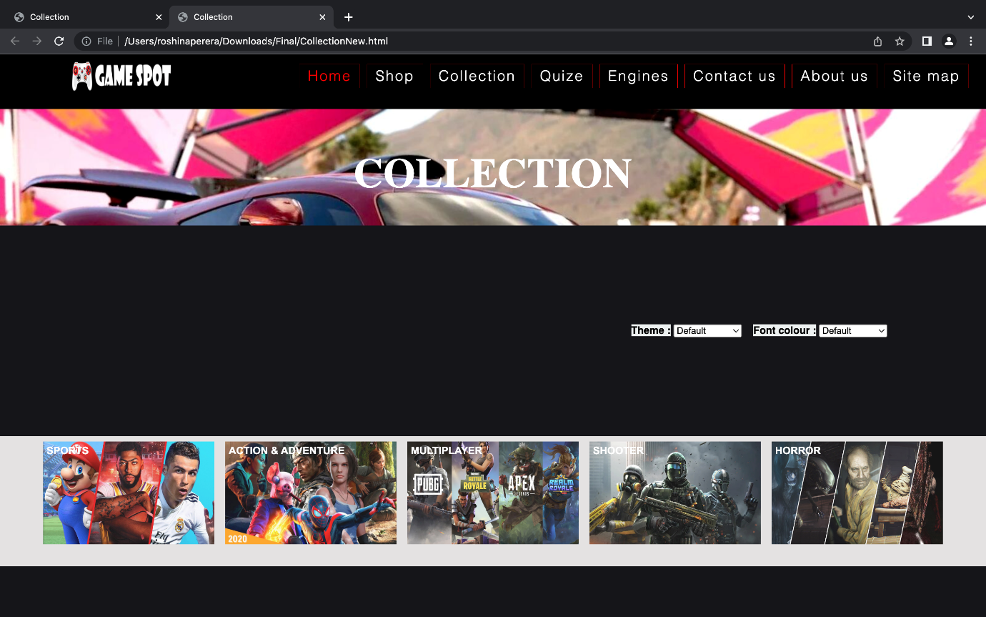

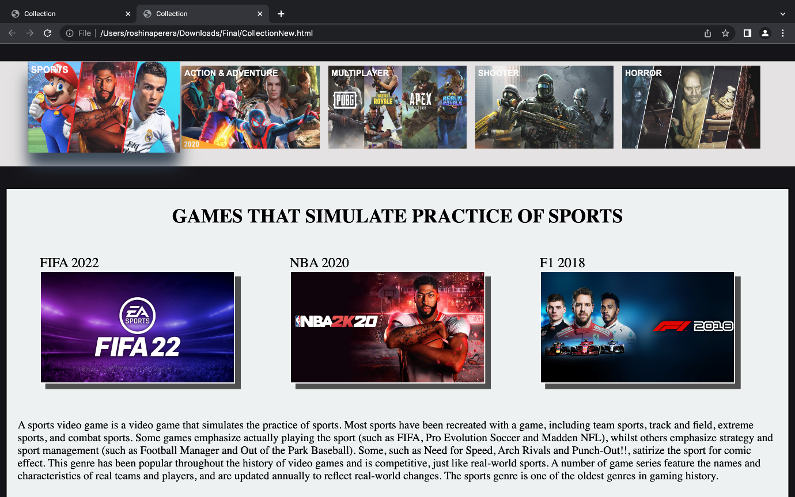

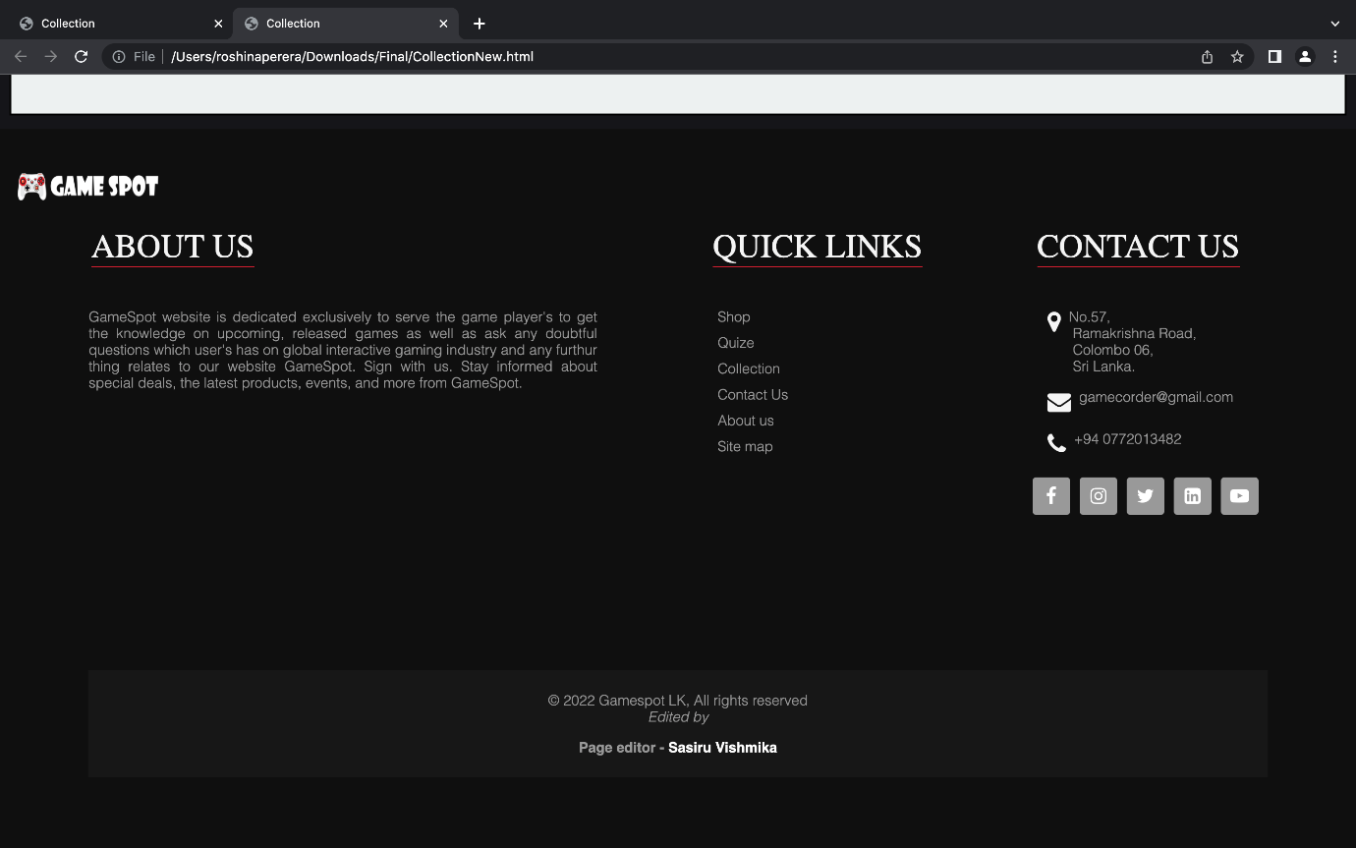

File name – Sitemap.html

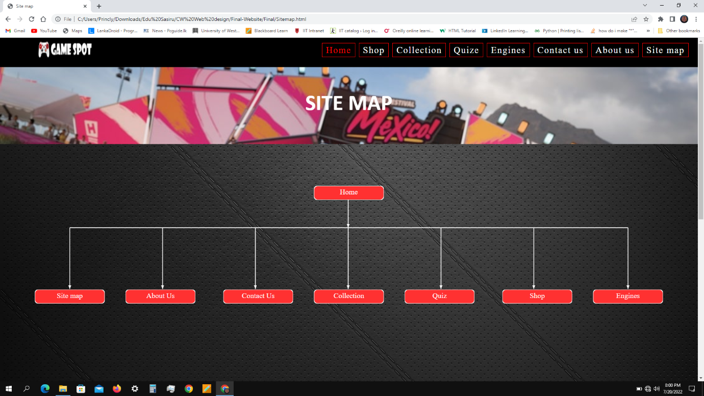

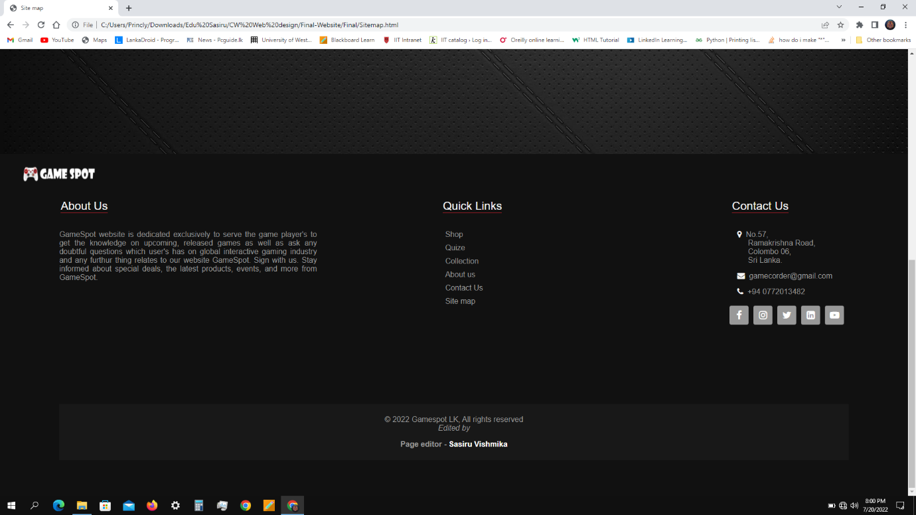

File name – PageEditor.html

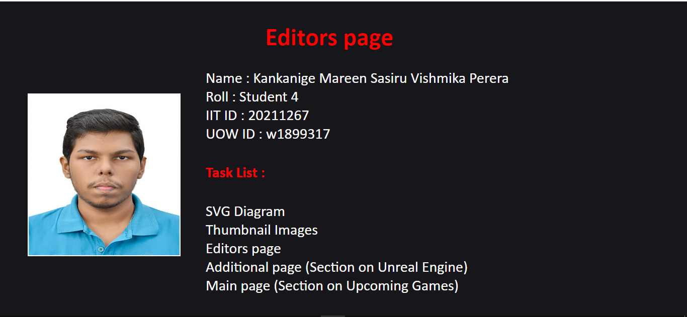

Game_Engines.html

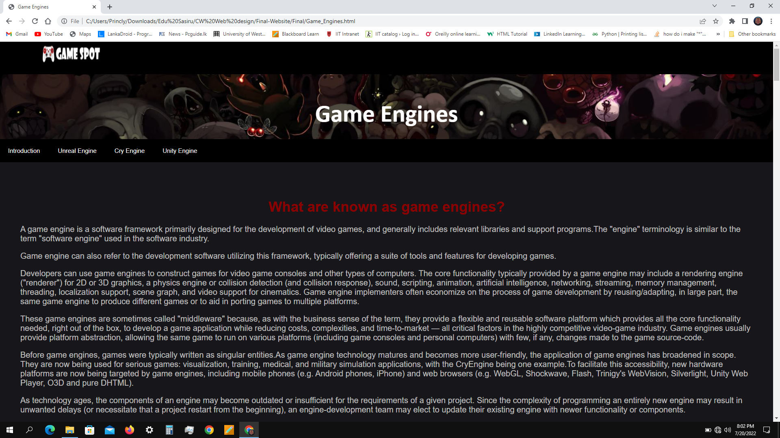

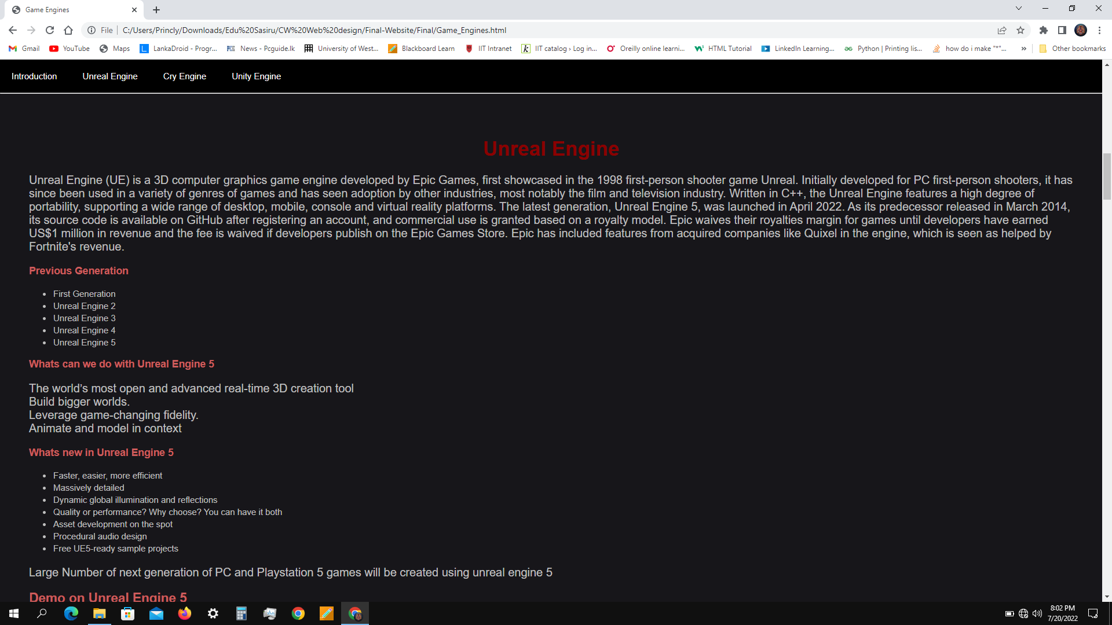

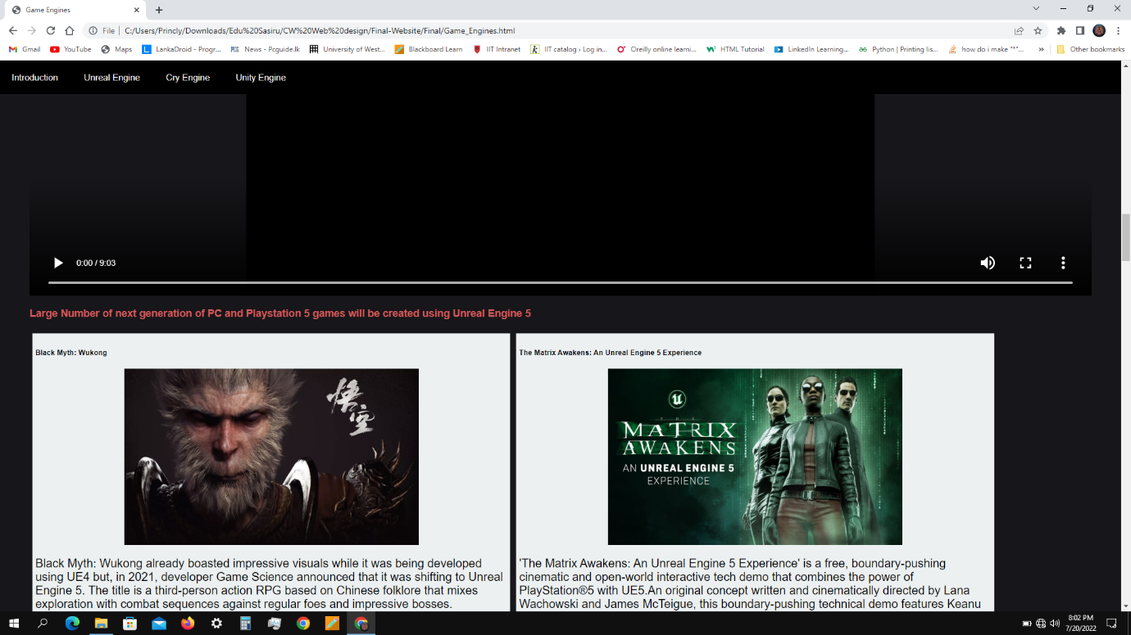

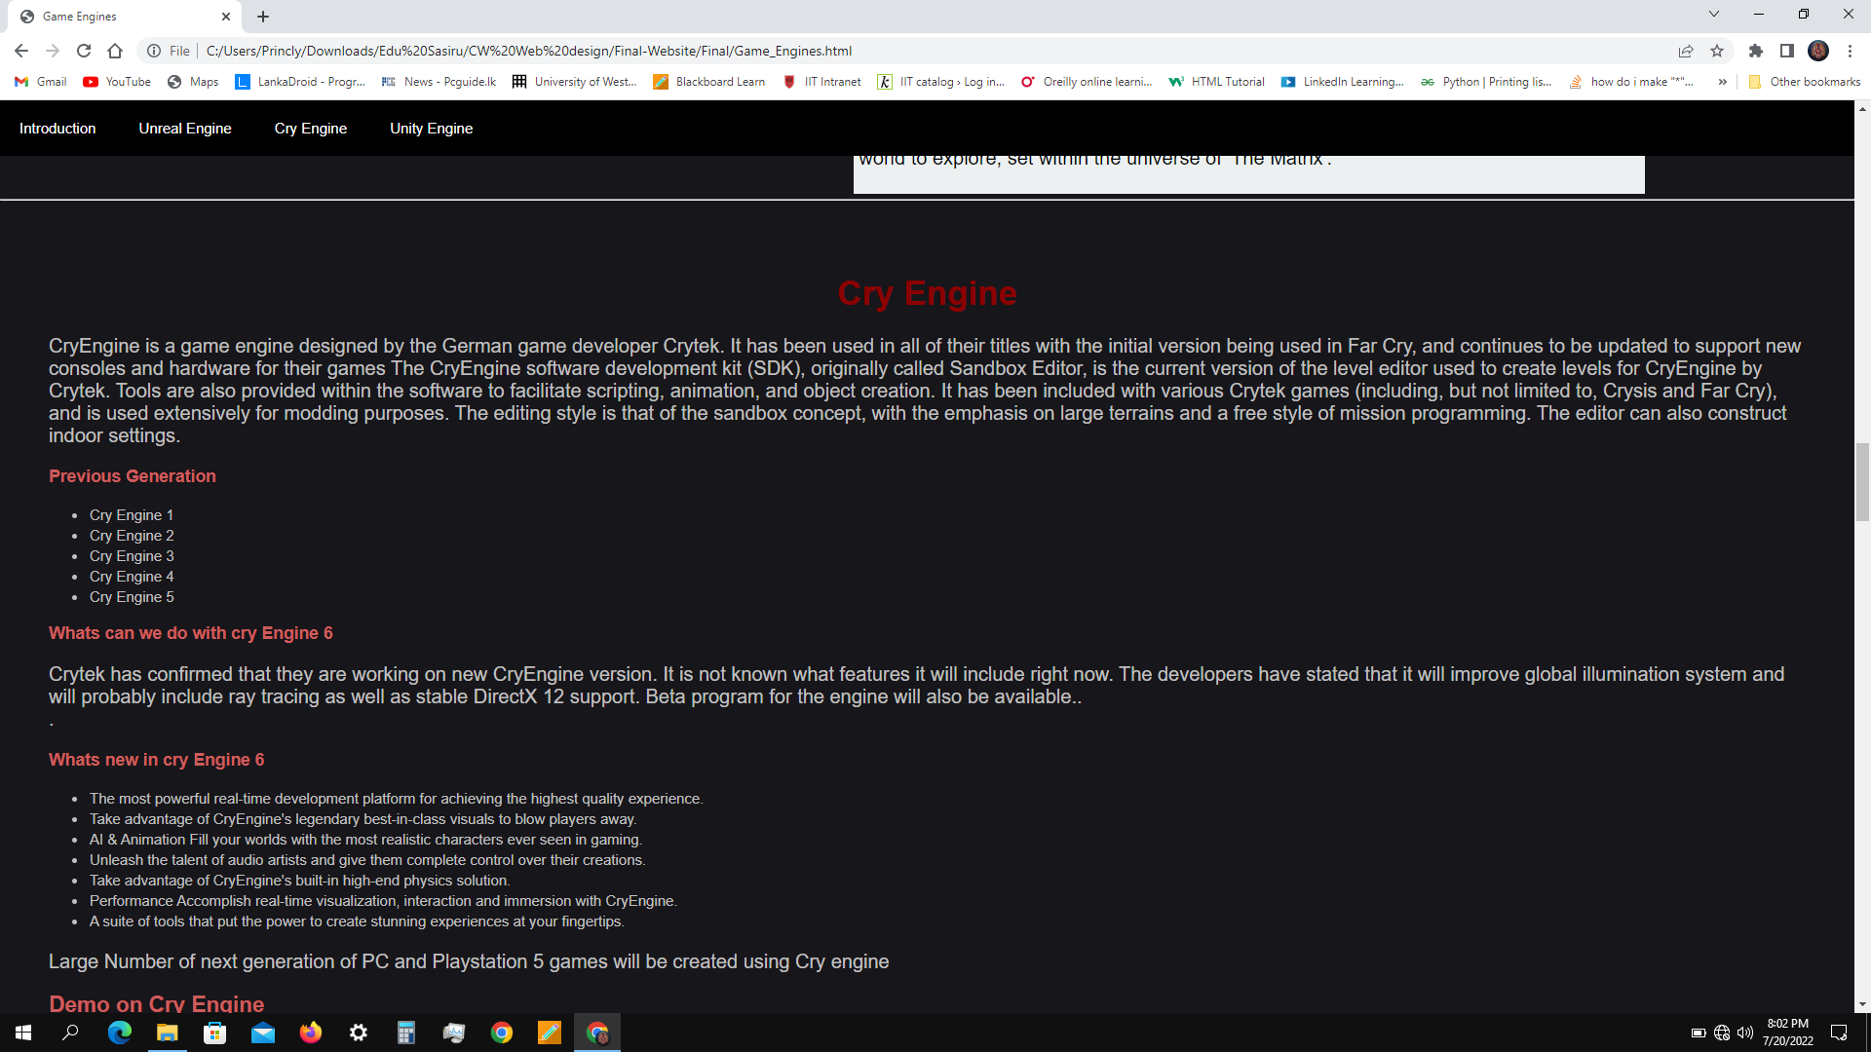

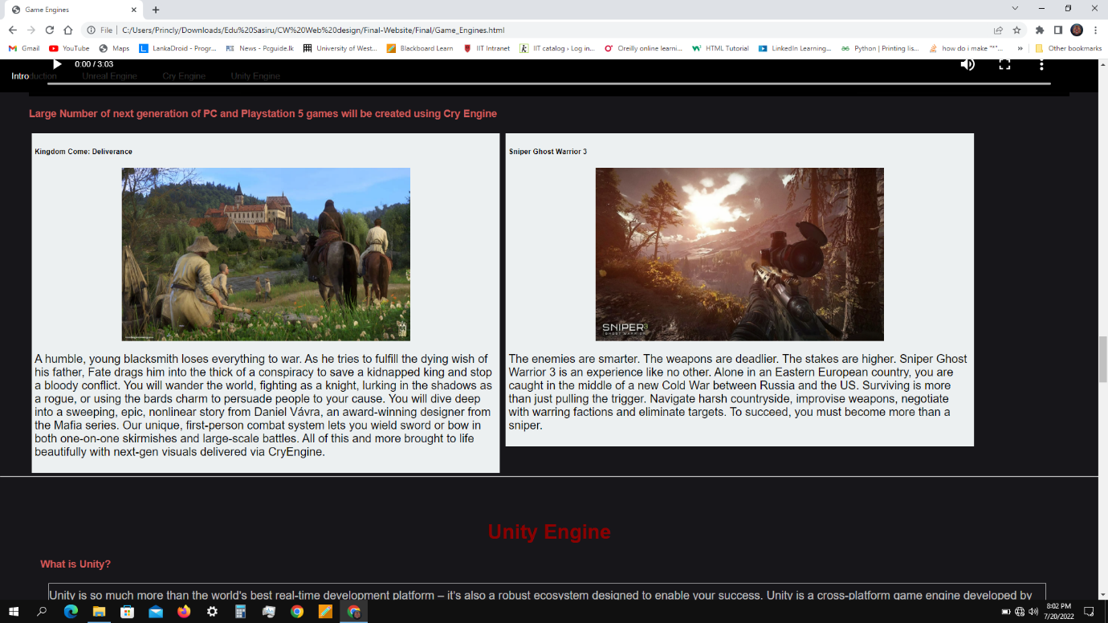

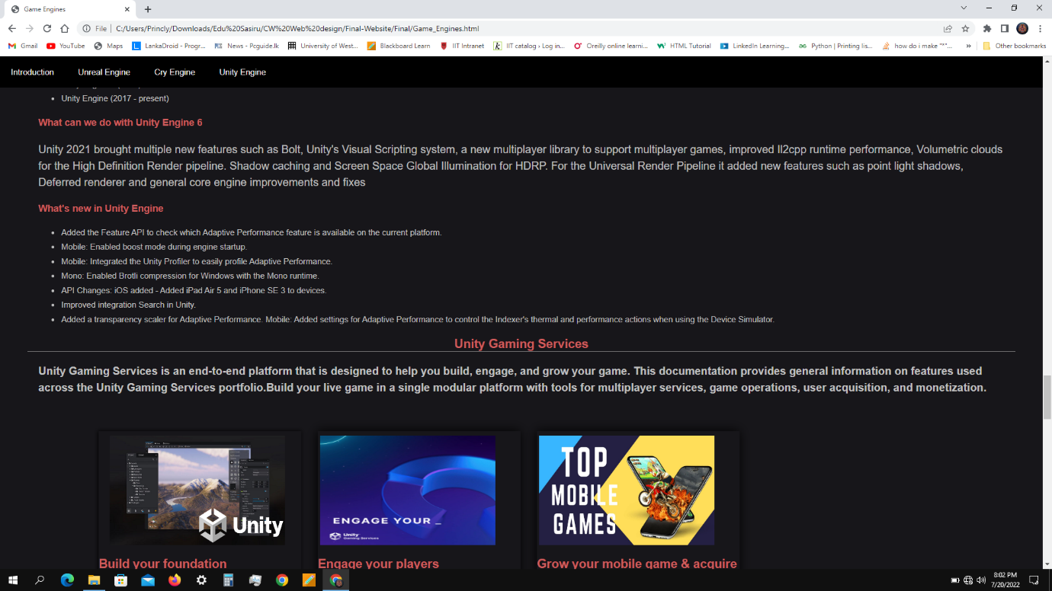

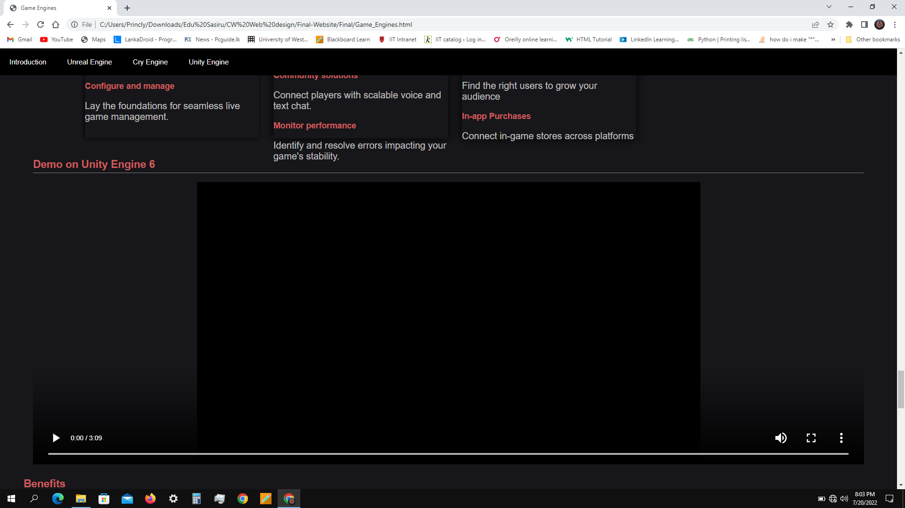

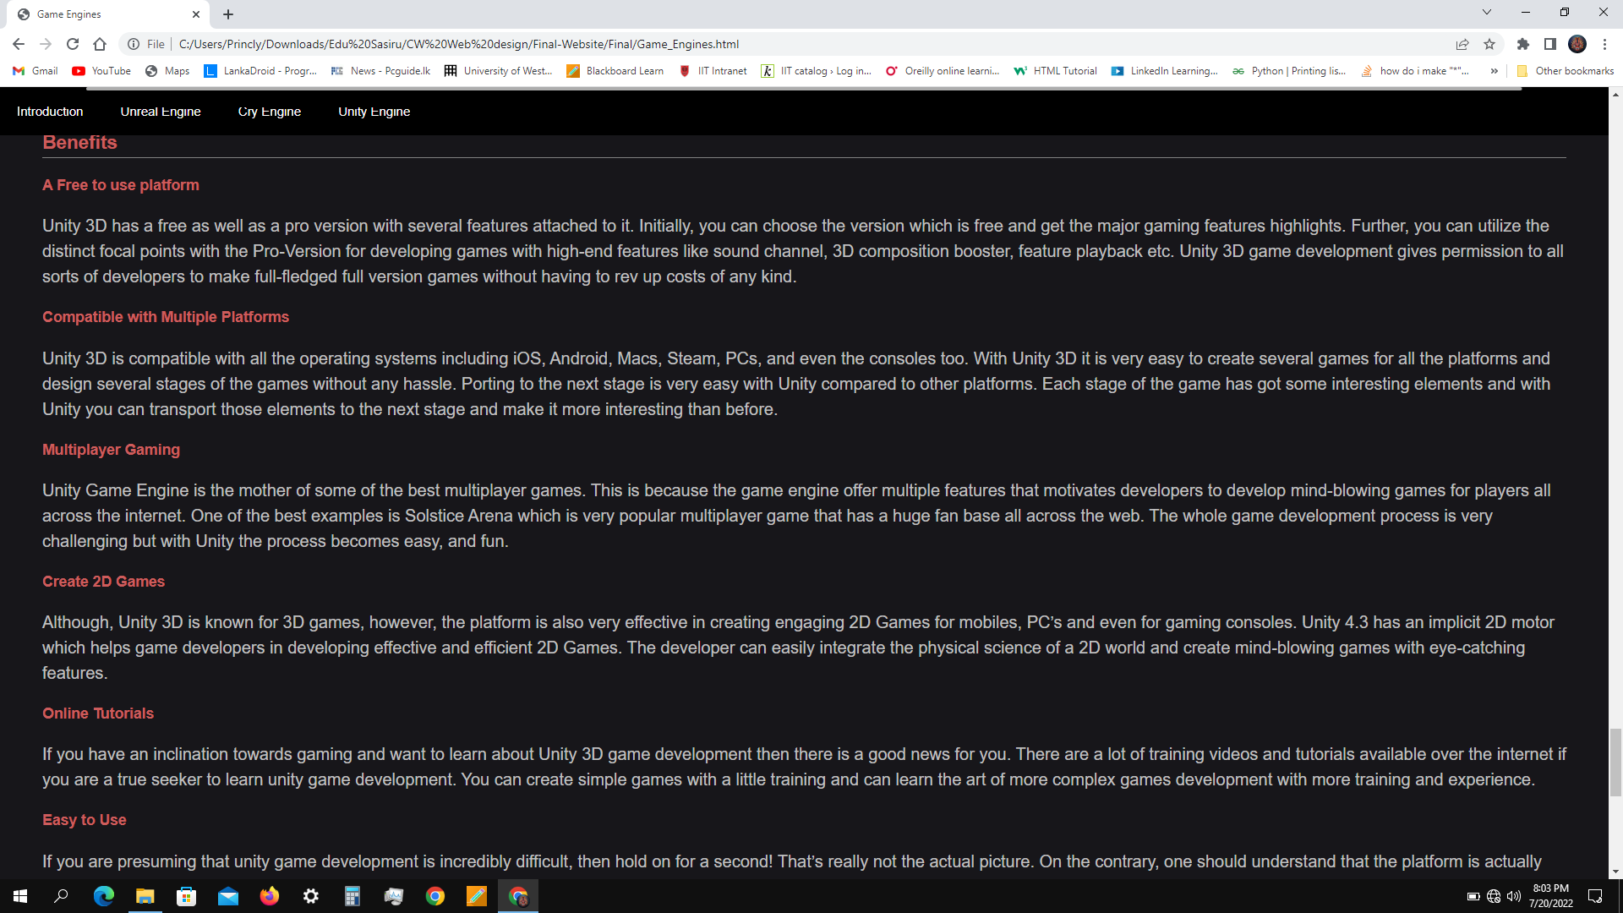

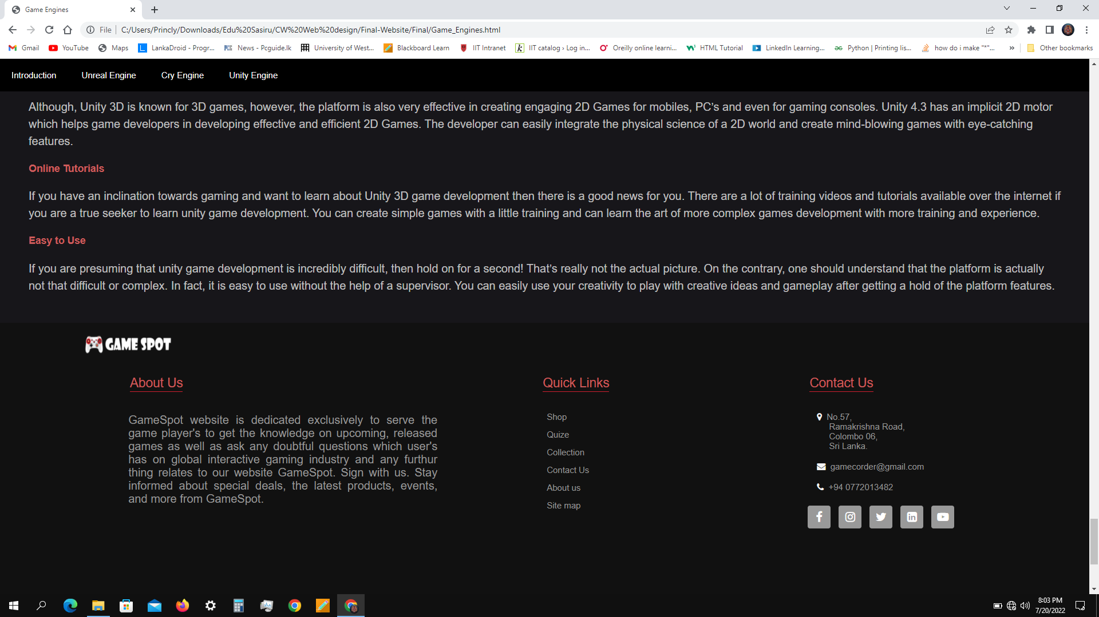

File name – mainpage.html

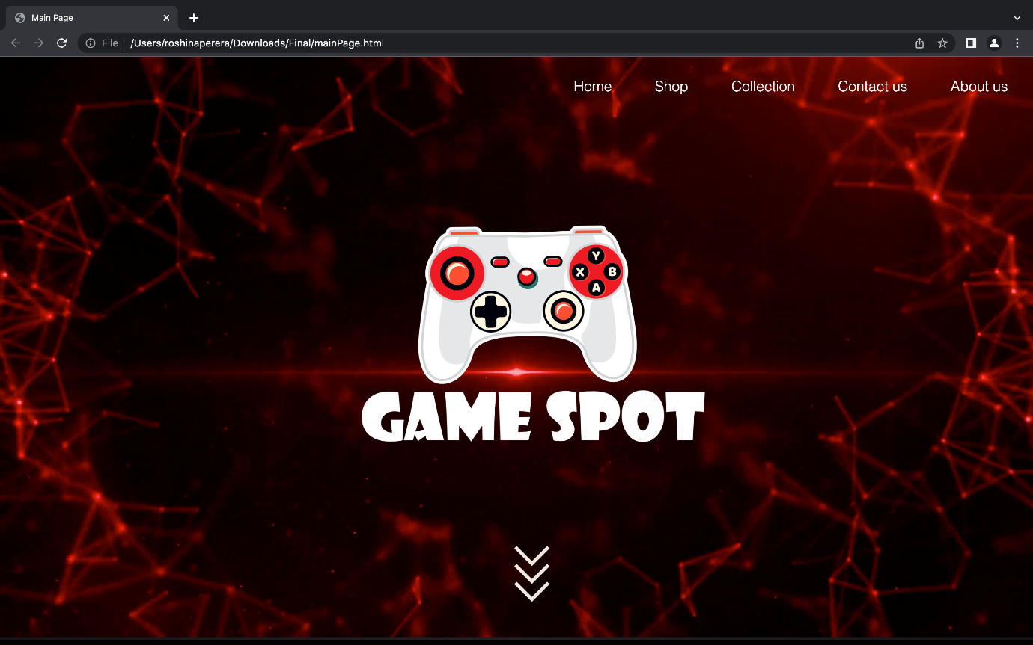

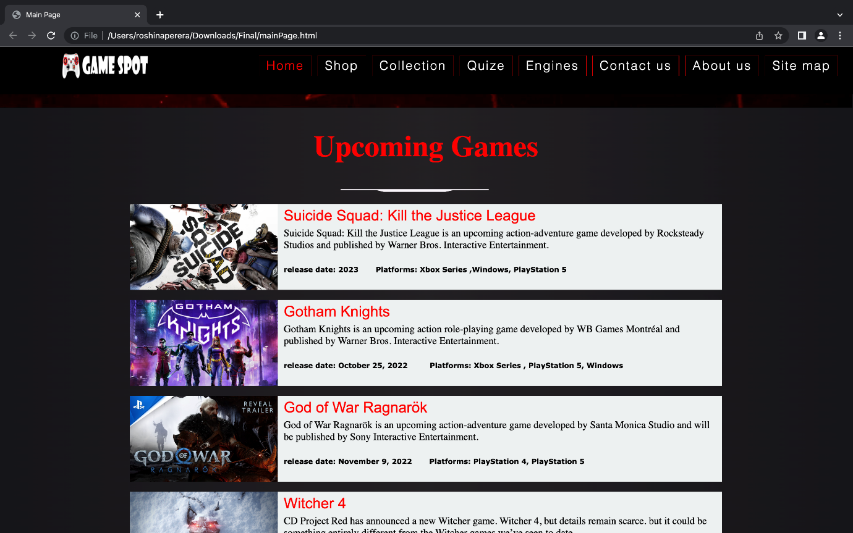

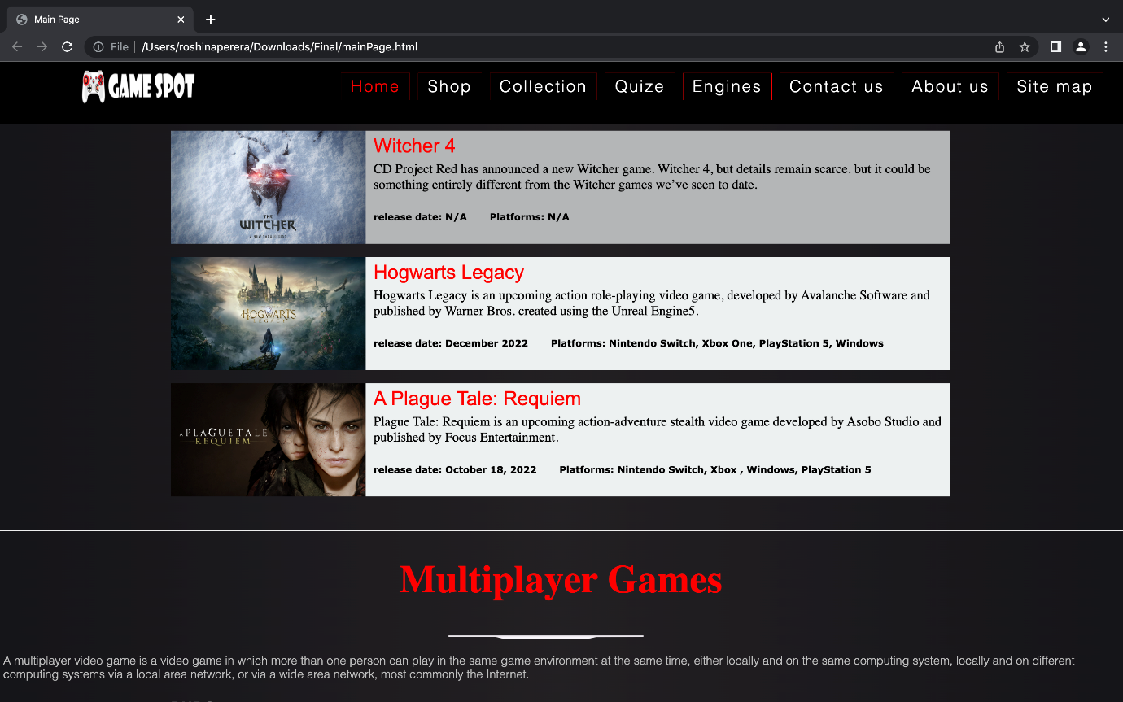

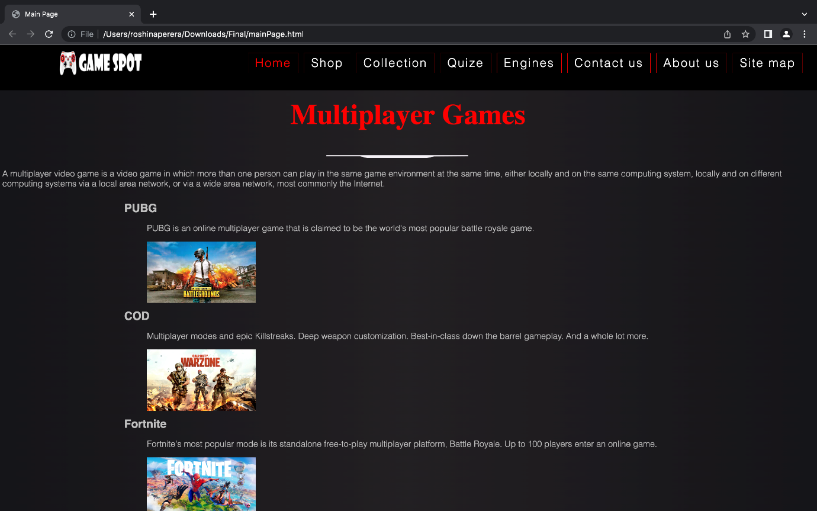

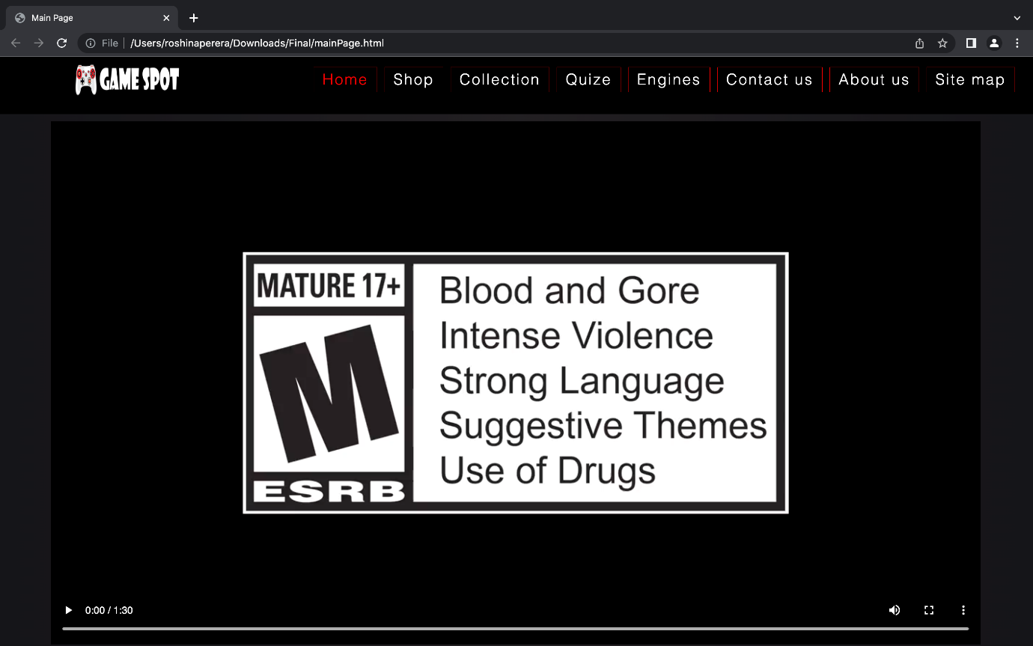

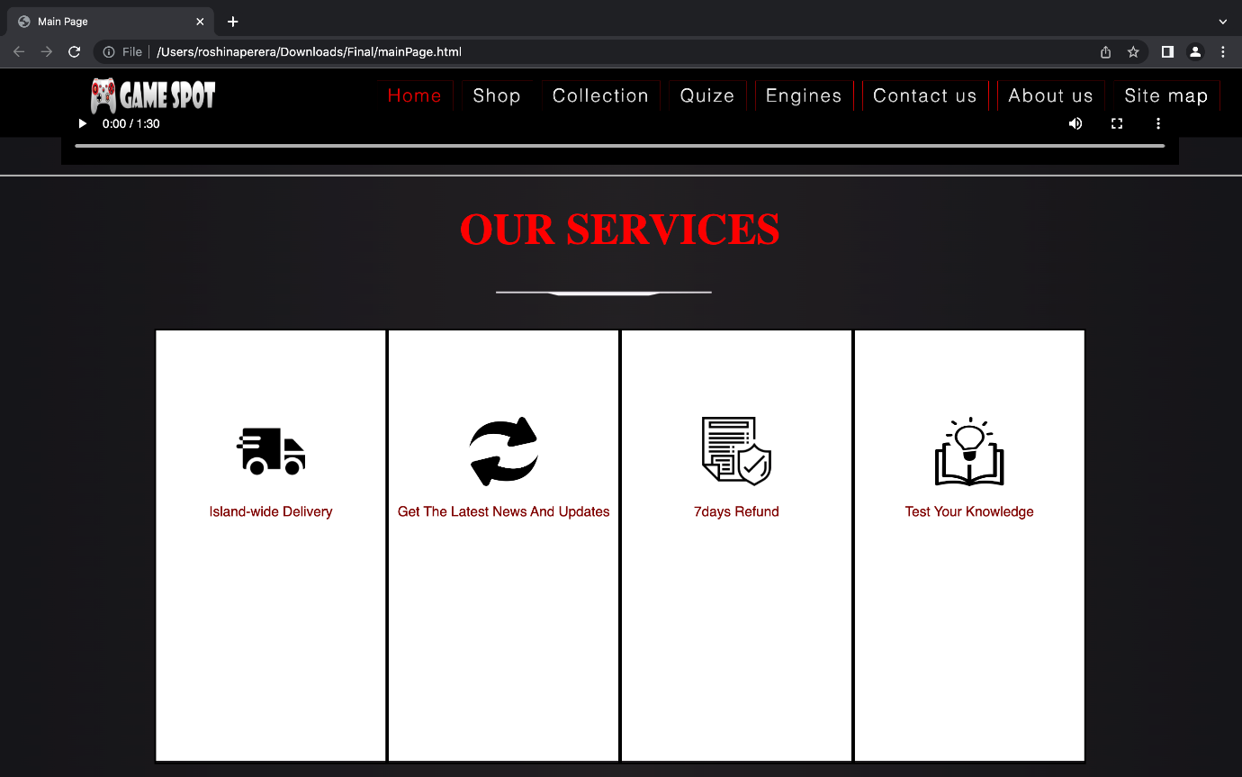



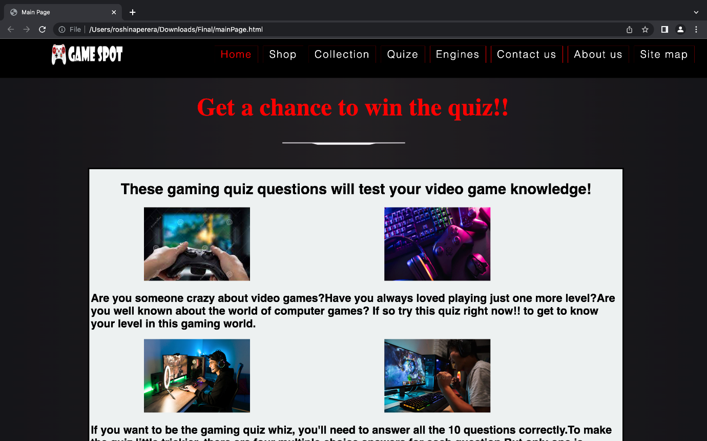

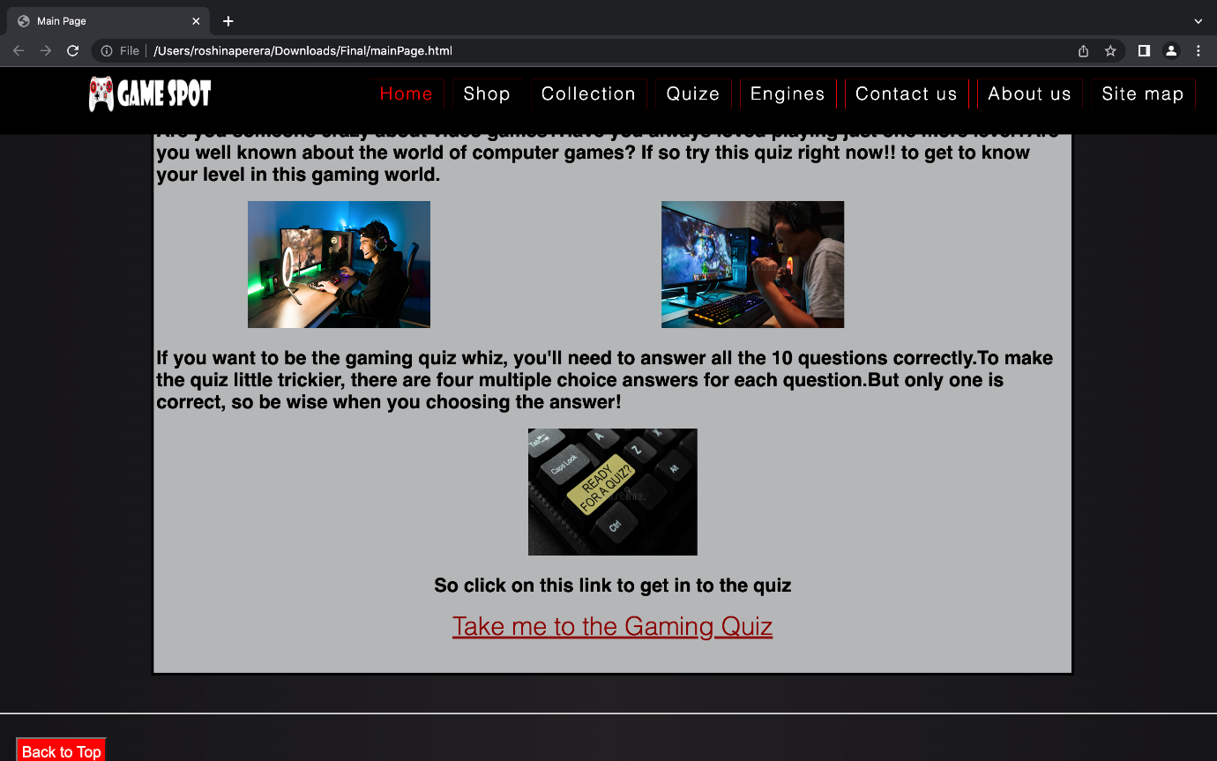

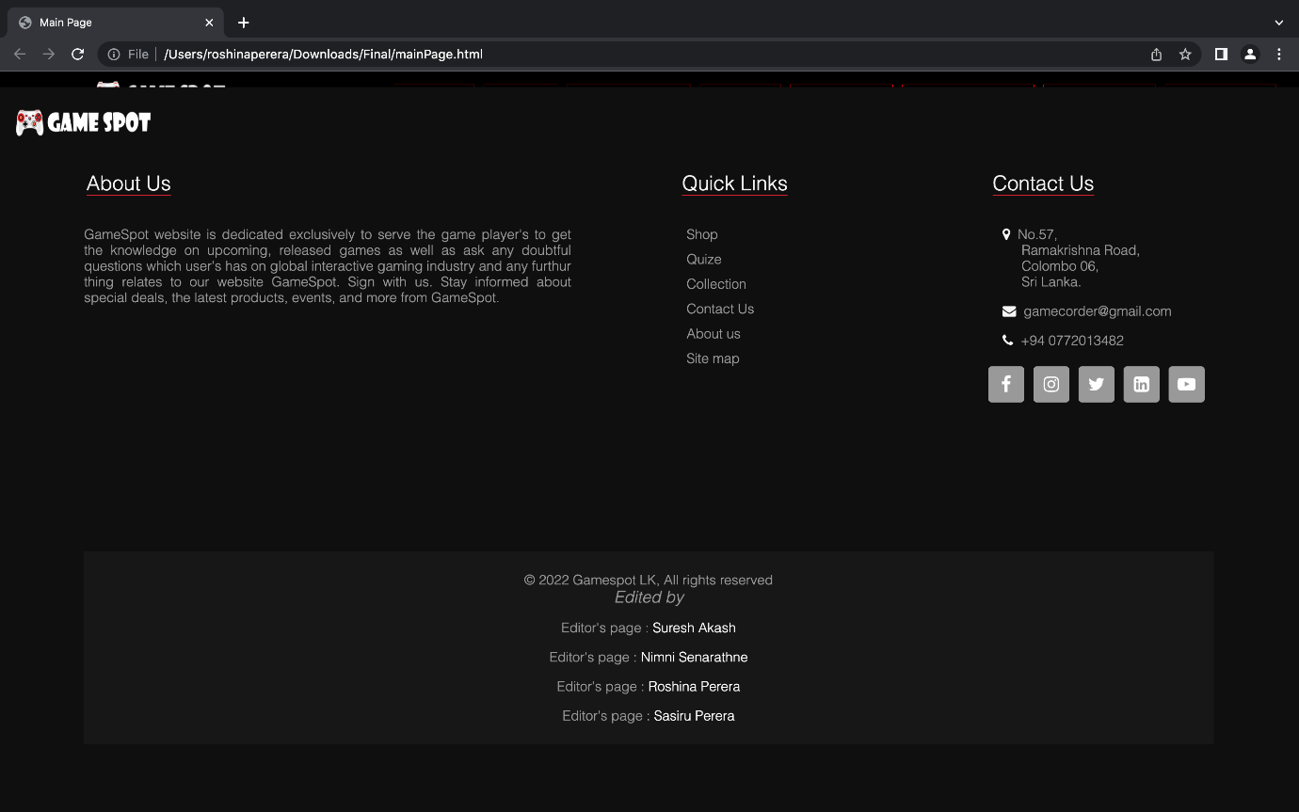

## Appendix C: Screenshots - Webpage Validation Evidence

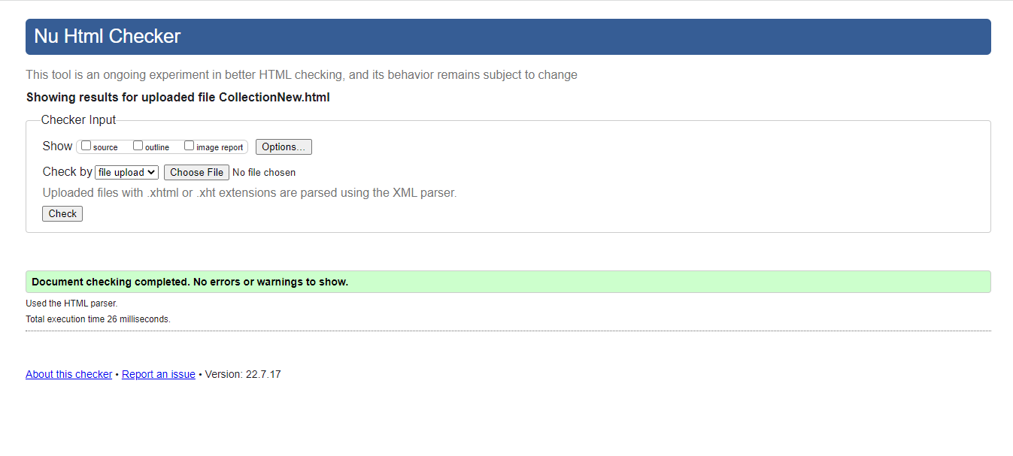

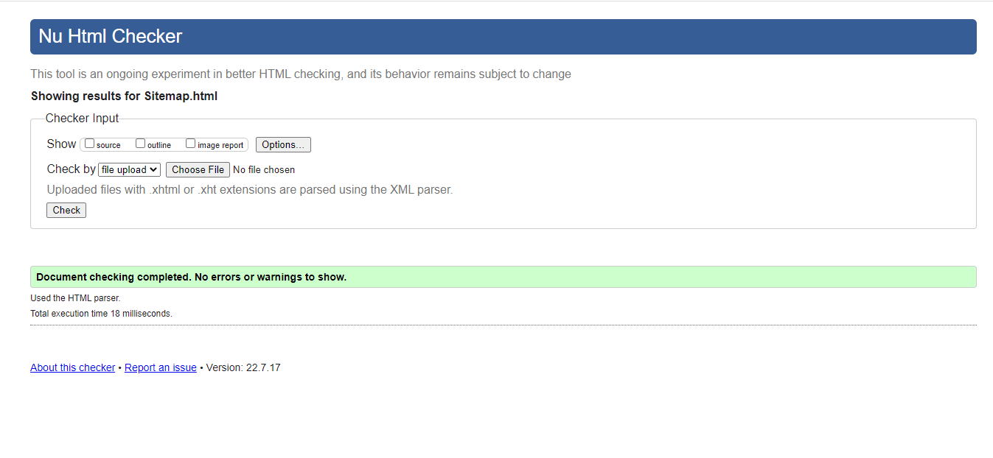

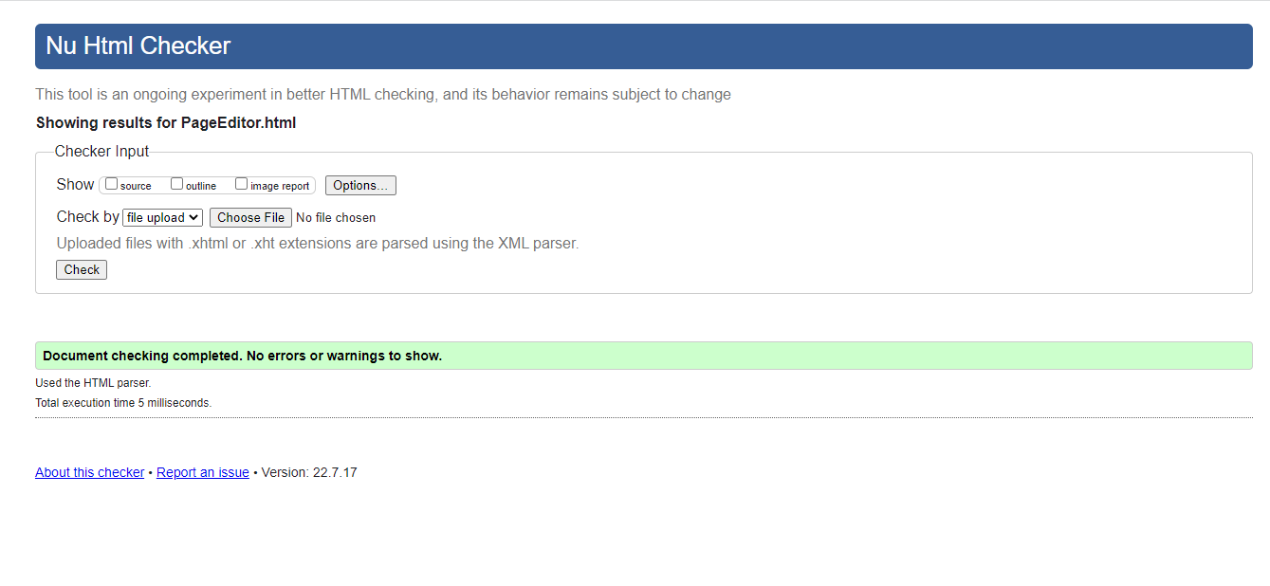

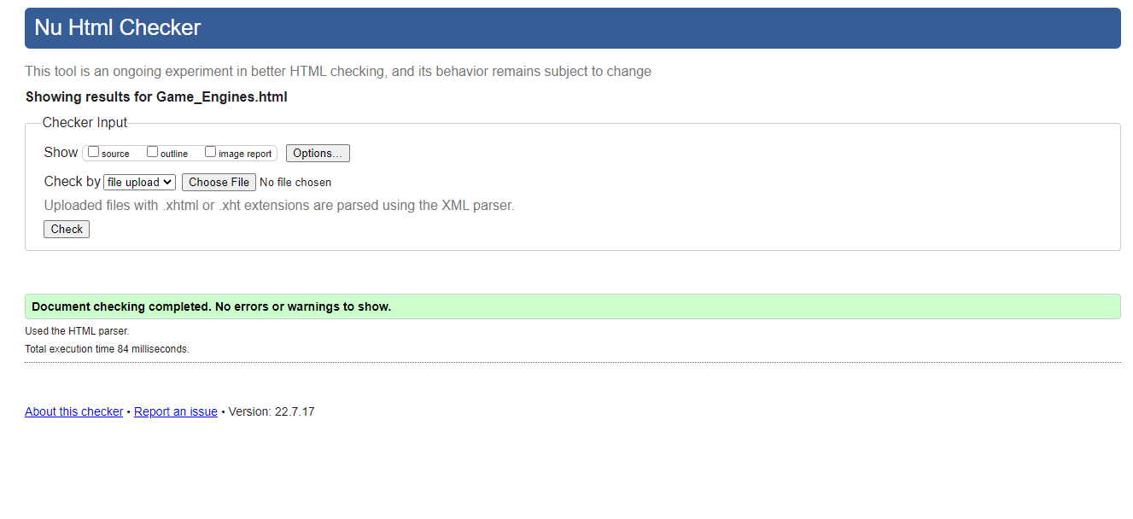

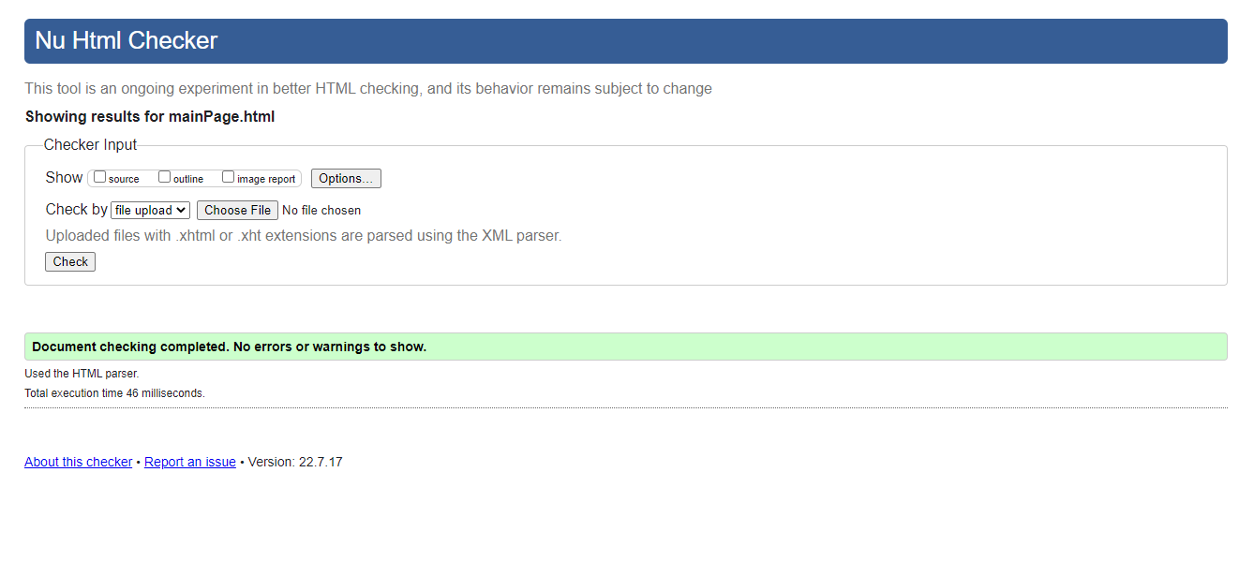

## Appendix D: Individual Statement

| Student Name: | K. Mareen Sasiru Vishmika Perera | Student Id: | 20211267/w1899317 |
| --- | --- | --- | --- |
| State what tasks you carried out in the project. | | | |
| Create a sitemap diagram using svg.  Create a Thumbnail images page.  Create page editor’s page. | | | |
| State what you enjoyed and did not enjoy about teamwork. | | | |
| Teammates were friendly and I was able to improve my knowledge on coding and other designing method.  We struggle a little bit when we merged all content into one website some of the styling used that worked fine for individual page did not work according to how we preferred when we used them in main website, we had to edit them. | | | |
| State what you learnt about teamwork. | | | |
| Time management.  Team spirit.  How to interact with other team members. | | | |
| State what skills you gained/learnt from undertaking the project. | | | |
| I learned how to design a website according to new trending layout designs.  I improved my coding knowledge on javascript, html and css.  Teamwork. | | | |
| State any strengths about yourself that emerged whilst undertaking the project. | | | |
| I learned I was able to do the layout design creatively  Good teamwork and time management. | | | |
| State any weaknesses about yourself that emerged whilst undertaking the project. | | | |
| We couldn’t fix some of the errors with main and additional page, so I realized Its hard for me to work under pressure like that I get stress out a lot. | | | |
| State how you would do things better if you were to undertake the project again. | | | |
| I would use a more suitable version control system as GitHub since we used google drive it was lot of work when we fix the final website. | | | |
| Additional general or project specific comments: | | | |
| This project helped me to realize the value of good teamwork and I learn self-studying is the best way to improve our knowledge. | | | |